# Treyson’s Happy Casserole Site Plan

## Treyson Ricks

## WDD 130

## Overview

### Purpose

To celebrate the joy of the beloved delicacy, tater tot casserole.

### Audience

Those who want to be able to cook tater tot casserole and be happy.

The overall mood of the site is someone who really wants to share their recipe with others despite them not knowing how to share it effectively. Hence the high details and “creative” pictures.

## Branding

### Website Logo

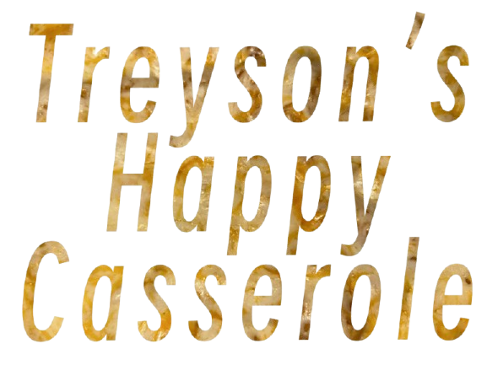

## Style Guide

### Color Palette

|  |  |  |  |
| --- | --- | --- | --- |
| **Primary** | **Secondary** | **Accent 1** | **Accent 2** |
| #C47A3C | #F3E5AB | #C94C36 | #9BA17B |

### Typography

#### Heading Font: Raleway

#### Paragraph Font: Open sans

### Navigation

Home Instructions History

**Content**

[put all content for the pages here, including written text and images]

**Home – About the chef paragraph**

Treyson is a cook with a strict passion for tater tot casserole. Growing up around the hearty and irresistible smell of tater tot casserole, he learned early on that this food is more than nourishment — it’s connection. Treyson’s signature dish, his famous Tater Tot Casserole, combines nostalgic flavor with his own unoriginal style. Whether he’s trying to cook tater tot casserole or consider making something other than tater tot casserole, Treyson’s goal is simple: to bring people together over a dish that always tastes like tater tot casserole… and to learn how to cook stir fry.



**Home - Tater tot casserole description**

Tater Tot Casserole is the ultimate comfort, homey, nostalgic, soul-satisfying, heartwarming, home-cooked, satisfying, soothing, indulgent, wholesome, hearty, cozy, blissful, consoling, familiar, simple, grounding, peaceful, old-fashioned, cherished dish — a warm, golden-baked blend of crispy tater tots layered over a savory mixture of meat, creamy sauce, and tots. It’s simple to make, endlessly customizable, and loved by families across America for its balance of texture and taste. Every bite delivers the perfect combination of crunch and comfort, making it a timeless favorite at dinner tables everywhere.

**History – The history of tater tot casserole**

**A Detailed History of Tater Tot Casserole in the United States**

The history of tater tot casserole begins long before anyone ever layered tots over a baking dish. It starts in the early 1950s with the founders of Ore-Ida, the potato-processing company owned by the Grigg brothers. While cutting potatoes into fries, they were left with tiny shreds and scraps. Rather than waste them, the brothers found a way to reshape the pieces, season them, and bind them together. In 1953, these bite-sized cylinders were officially introduced to the world as tater tots — an affordable, clever example of food innovation.

At first, tater tots weren’t a household staple. Grocery stores often placed them on the bottom shelves, and home cooks weren’t quite sure what to do with them. But their cost, convenience, and crispiness quickly won people over. American families in the post-war era were eager for foods that were easy, filling, and budget-friendly — a perfect environment for the tot to shine. In only a few years, tots had secured a comfortable place in freezers across the country.

The casserole portion of the story was already quietly unfolding in the Midwest, where community gatherings, church suppers, and family reunions were practically powered by hot, bubbling dishes. In states like Minnesota, North Dakota, and Wisconsin, casseroles weren’t just food — they were part of the social fabric. Ingredients were simple, affordable, and mixed together with practicality in mind. These early casseroles were often called "hotdishes," a regional term that still carries nostalgic weight today.

By the late 1950s and early 1960s, home cooks began experimenting with their newly beloved tater tots, and someone — though history never recorded exactly who — decided to spread them across the top of a hotdish. The result was a casserole that baked into something special: crispy on top, creamy underneath, and hearty all the way through. People loved how the tots acted like a built-in crust, making the dish feel both comforting and satisfying.

The earliest recognizable tater tot casserole recipes started appearing in community cookbooks in the Midwest. These were not formal culinary publications, but spiral-bound collections put together by churches, PTA groups, and local clubs. The recipes shared a common formula: ground beef, a can of cream soup, sometimes vegetables, and a layer of tater tots. Measurements were flexible, instructions were simple, and the dish was nearly impossible to mess up — everything a busy family needed.

As the 1970s rolled in, the casserole became even more deeply connected to Midwestern identity. Minnesota in particular embraced it so fully that “tater tot hotdish” became a cultural symbol. It was served at winter gatherings, weeknight dinners, harvest celebrations, and potlucks of every kind. Families passed down their own twists — some added cheese, others swapped meats, and a few insisted on specific brands of tots. It wasn’t just a dish; it was a tradition.

The casserole’s popularity spread across the United States thanks to two powerful forces: convenience foods and community cooking. Magazine ads, supermarket pamphlets, and recipe cards often highlighted ingredients like cream of mushroom soup, frozen vegetables, and tater tots. As more Americans entered the workforce, recipes that were quick, comforting, and cheap became staples. Tater tot casserole fit perfectly into the era’s growing love of easy, hearty meals.

By the 1980s and 1990s, the dish had fully cemented itself as a classic. Restaurants, diners, and school cafeterias began serving their own versions. Some introduced breakfast casseroles featuring eggs and cheese; others created Tex-Mex variations using taco seasoning. Tater tot casserole evolved with the times, proving surprisingly adaptable while still retaining its cozy roots.

In the 2000s, the casserole enjoyed an unexpected revival. The rise of food blogs, nostalgic cooking trends, and comfort-food restaurants brought renewed appreciation for everyday dishes that reminded people of childhood. Chefs playfully elevated the casserole with gourmet cheeses, caramelized onions, and fresh herbs — while still honoring the simple magic of baked tots.

Today, tater tot casserole remains a beloved part of American cuisine. Whether it’s served at a Minnesota potluck, a family dinner table, or a modern brunch spot, the dish represents everything comforting about home cooking: creativity born from frugality, traditions shared through generations, and the simple joy of a warm meal baked with care. Its history is humble, heartfelt, and thoroughly American — a story of potatoes, practicality, and the power of food to bring people together.

**Instructions with visual steps**

Ingredients

* Cooking spray
* 2lbs of ground beef
* 1 bag of onion seasoning
* 1lb of sour cream
* About 81 frozen tater tots
* 2 cups of shredded cheese

Cookware

* 1 oven
* 1 Skillet
* 1 meat chopper
* 4-8 paper towel sheets
* 1 9x13 inch baking pan
* 1 timer

Step 1 – Preheat the oven for 350°F

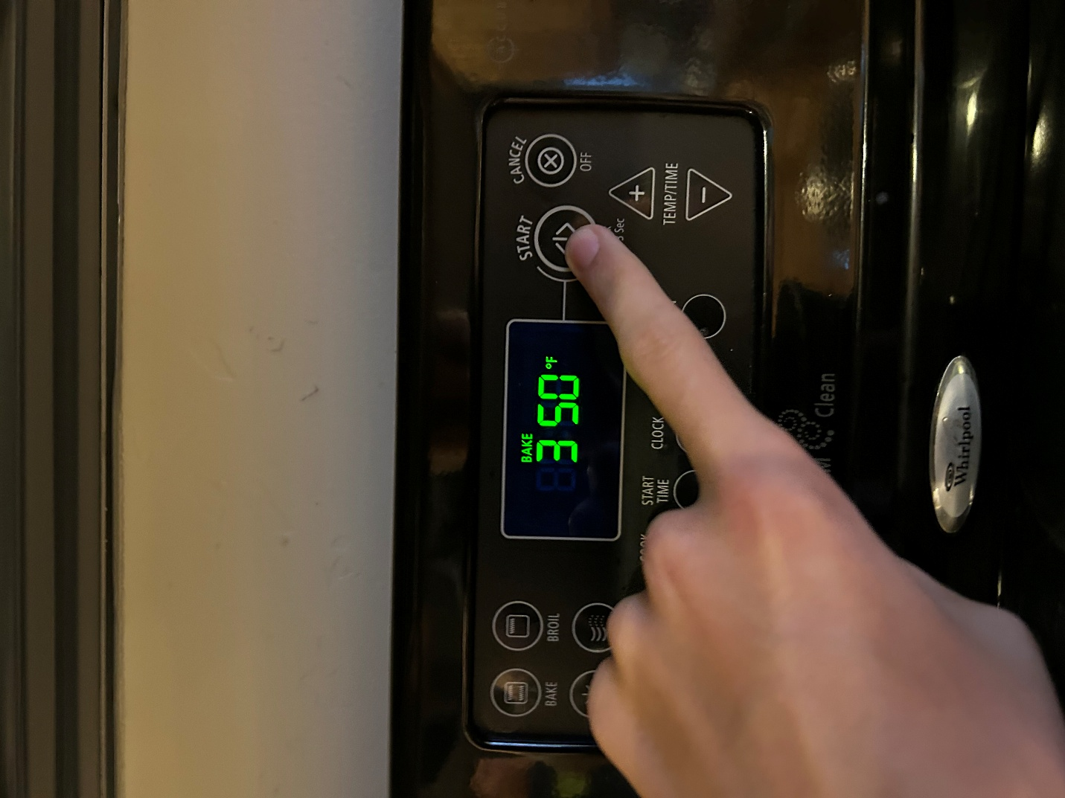

Step 2 – Acquire a skillet and spray it with a fine coat of cooking spray

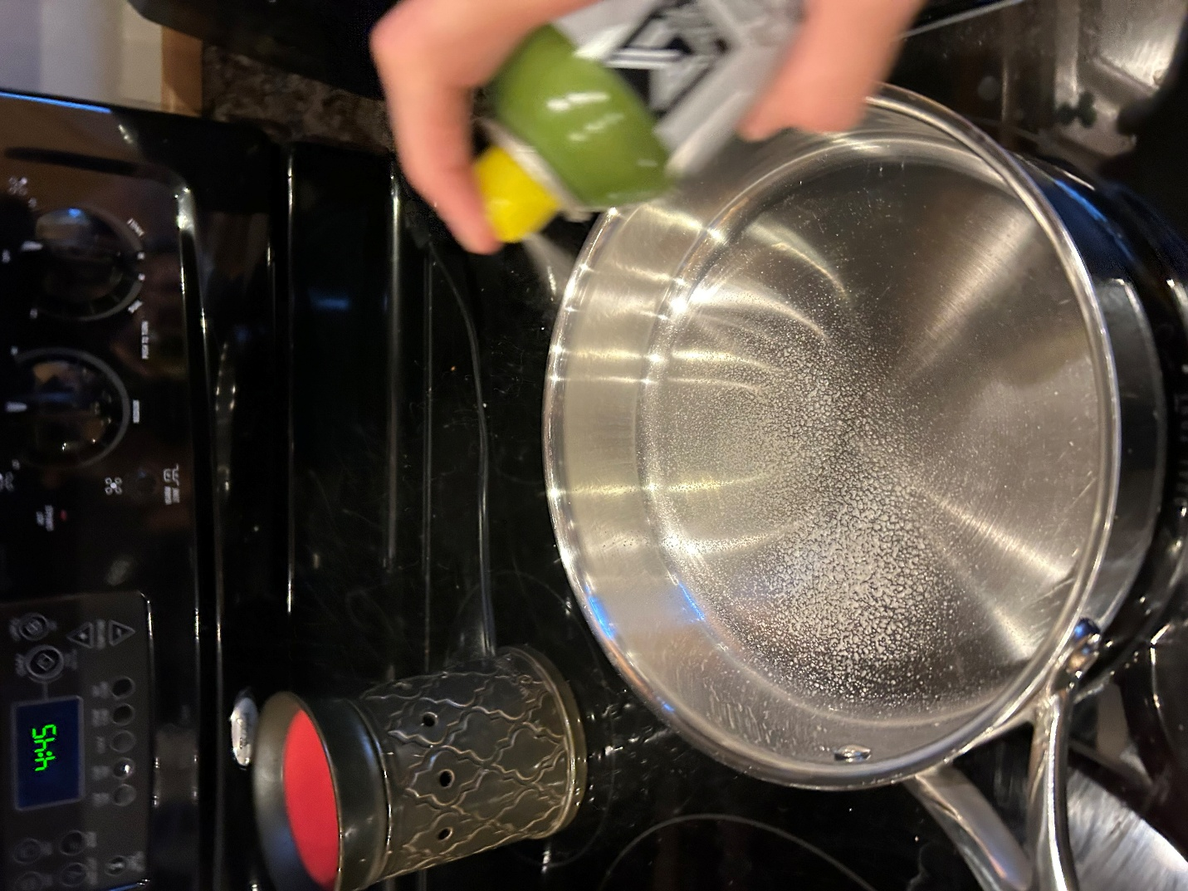

Step 3 – Turn the stove on medium-high heat

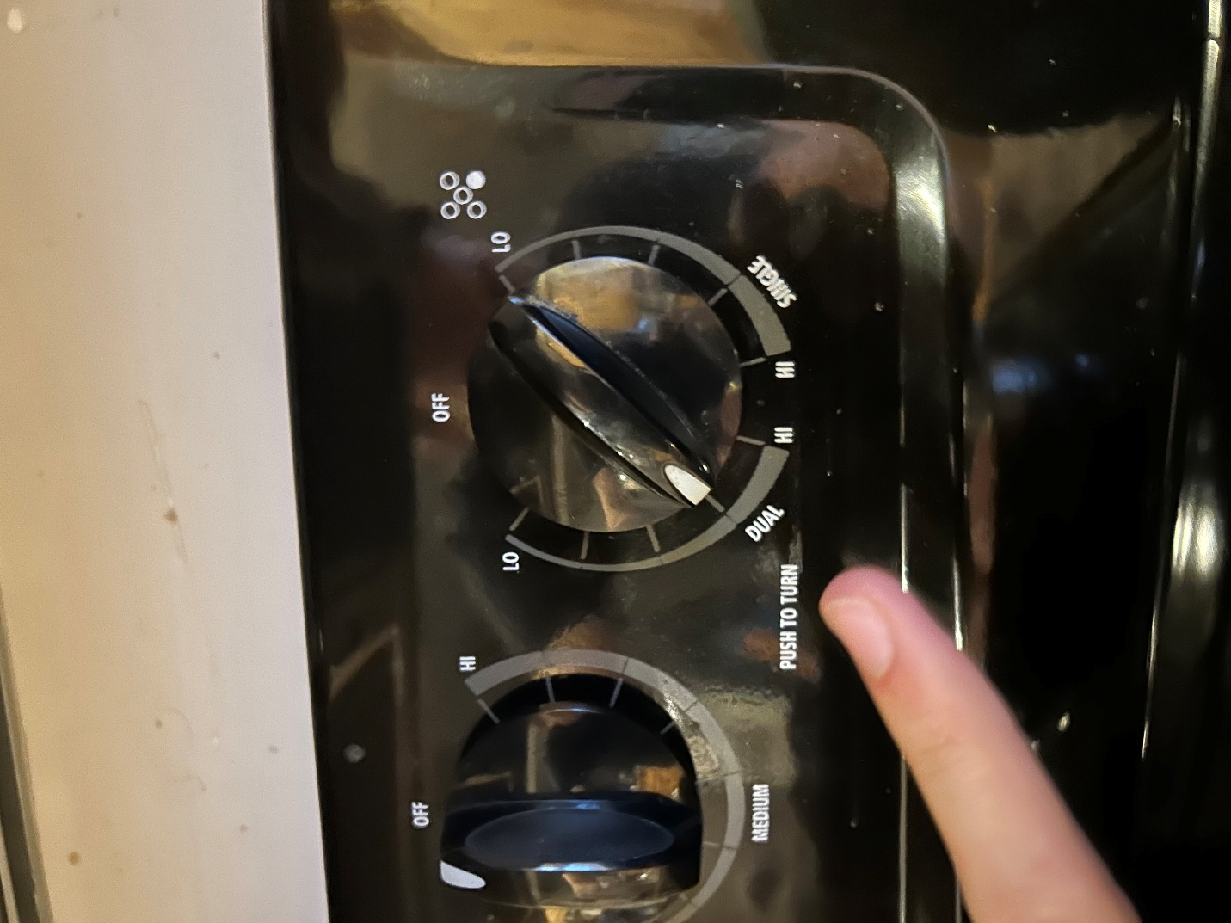

Step 4 – Acquire 1lb of ground beef and place it in the skillet.

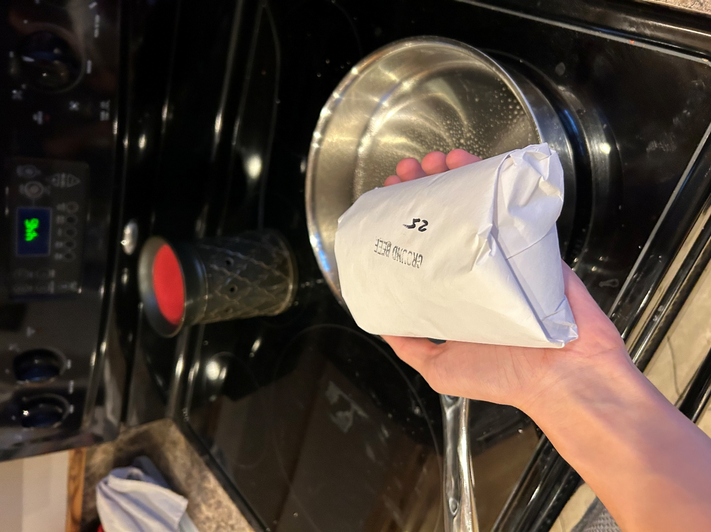

Step 5 – Acquire another 1lb of ground beef and place it in the skillet as well.

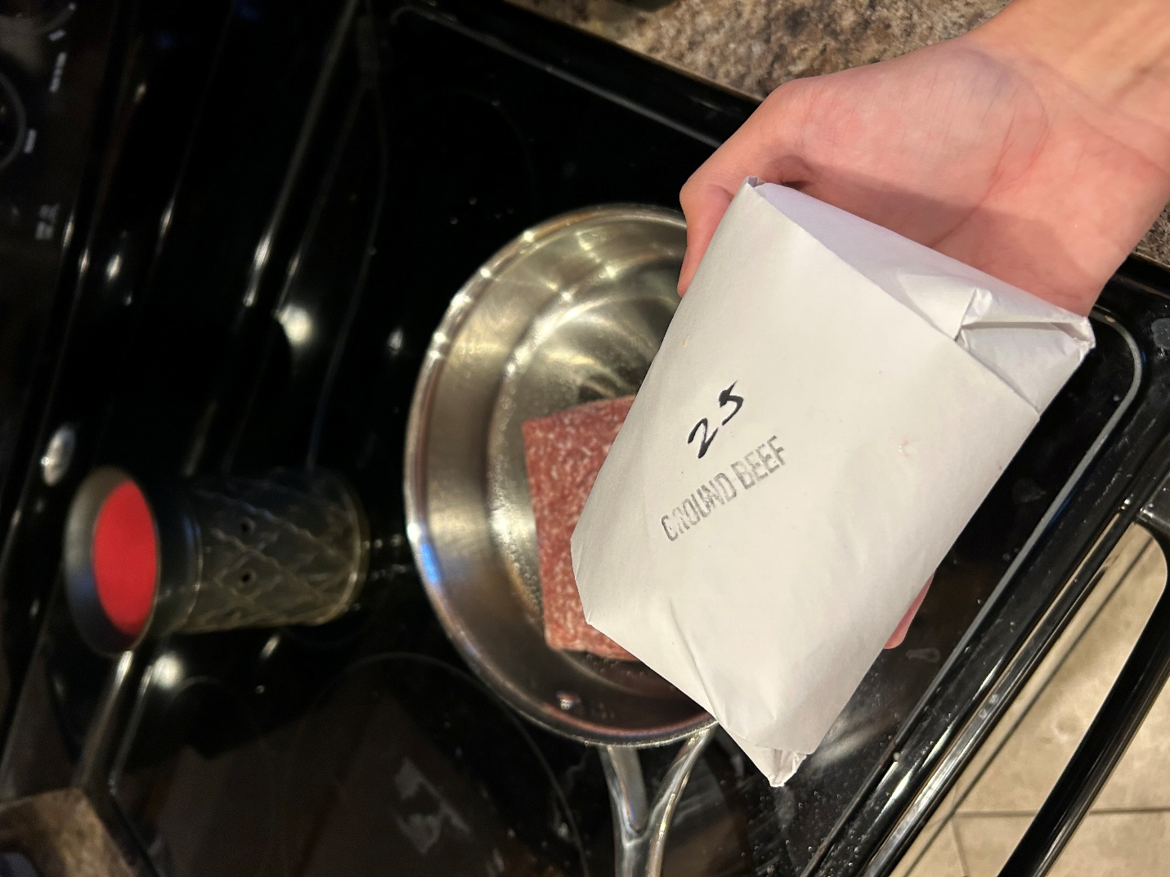

Step 6 – Acquire and use a meat chopper to mash the ground beef into itty-bitty pieces (you can decide how little “itty-bitty” is.

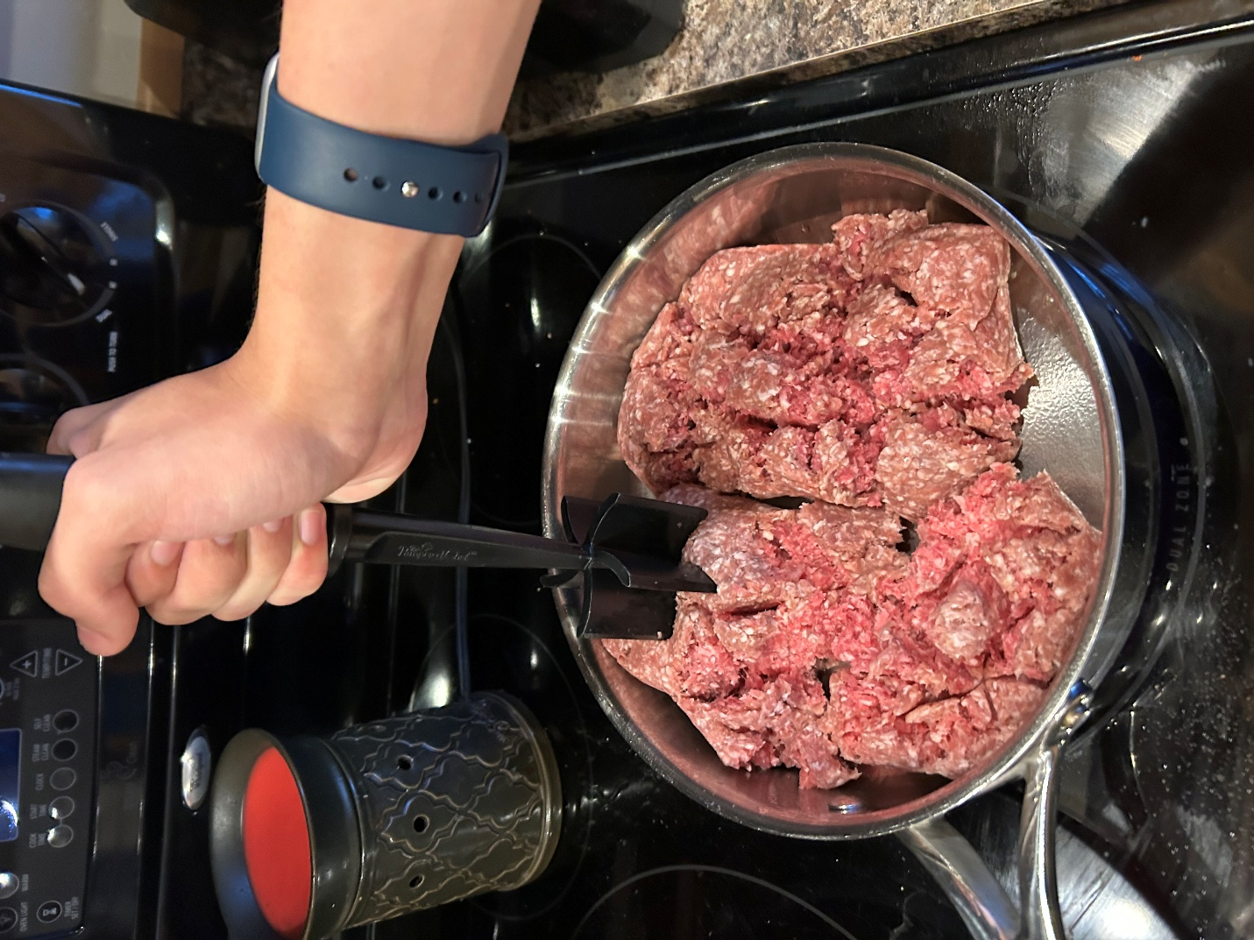

Step 7 – Continue to mash the meat while stirring it in the skillet until it is all brown.

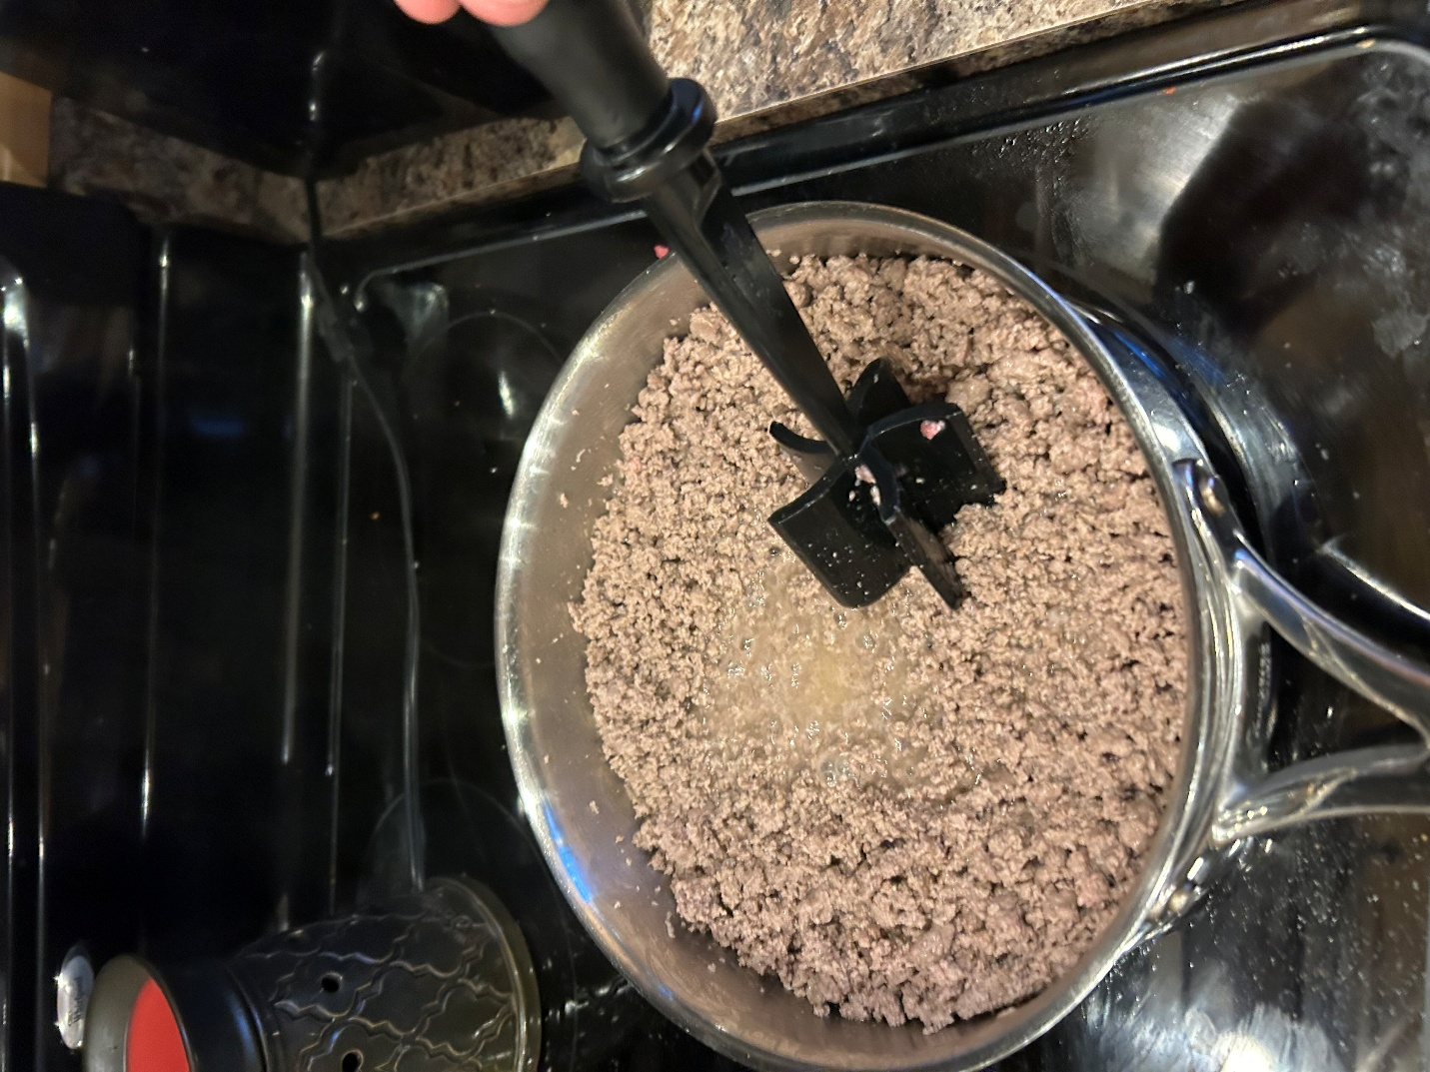

Step 8 – This step is optional, but I think it’s healthier ¯\_(ツ)_/¯. Acquire a few paper towels and soak up the grease produced while cooking.

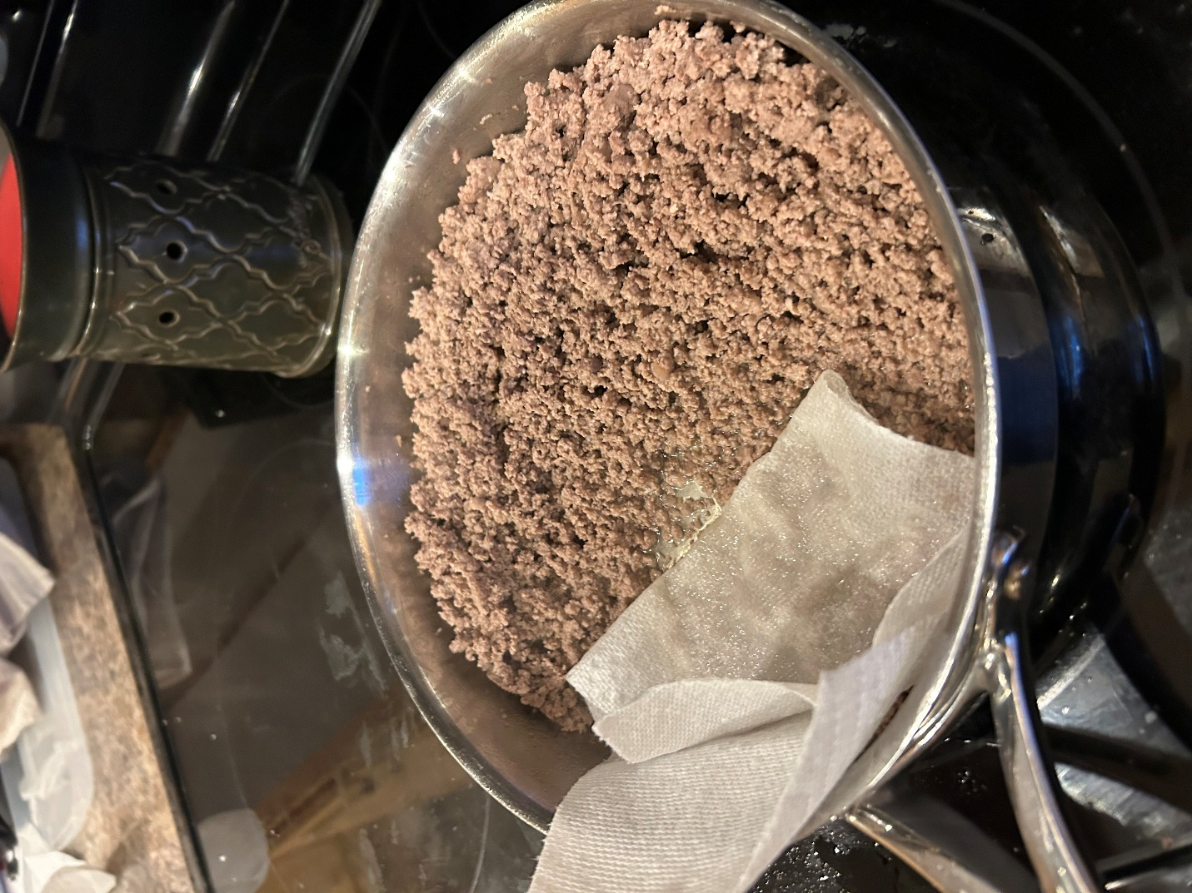

Step 9 – Acquire a packet of onion seasoning and sprinkle it throughout the meat. 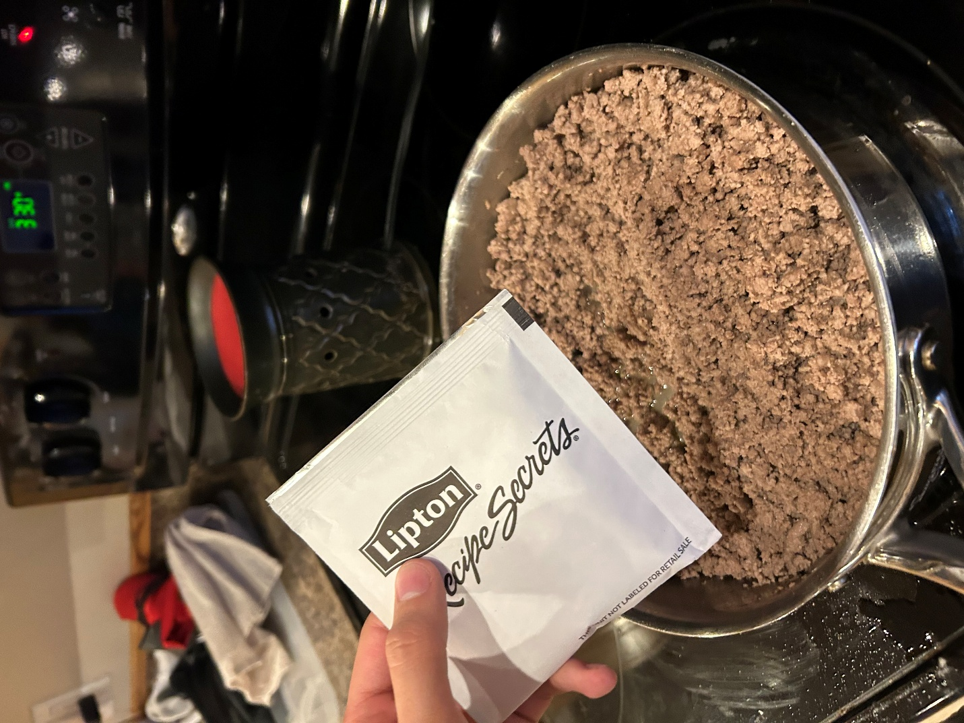

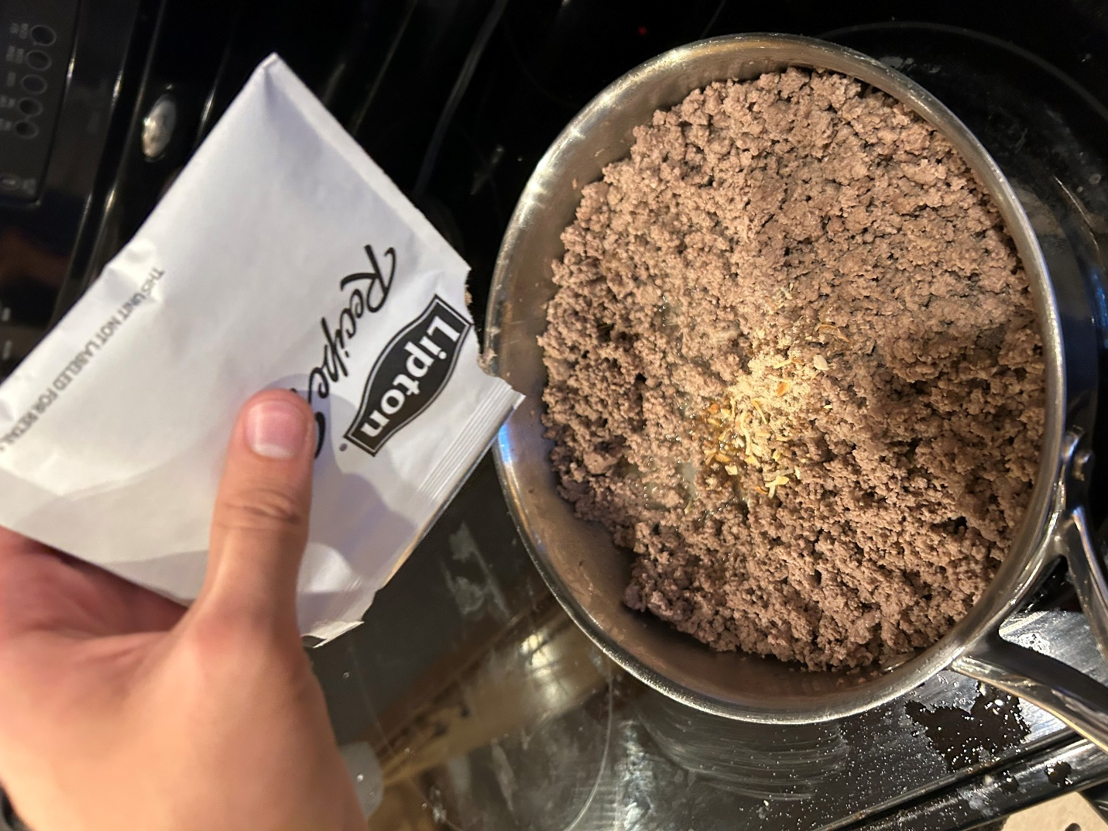

Step 10 – Acquire 1lb of sour cream and dump the entire thing into the pan. Stir the meat until the sour cream has bonded with it.

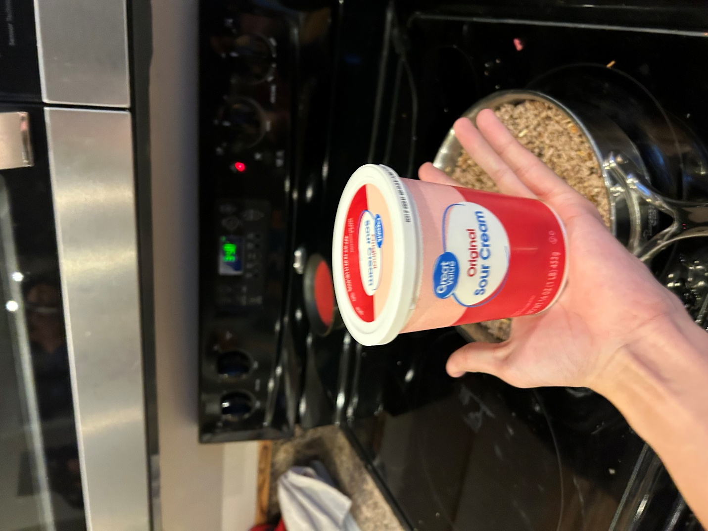

*Every picture is necessary. We don’t want anyone to get lost while cooking.*

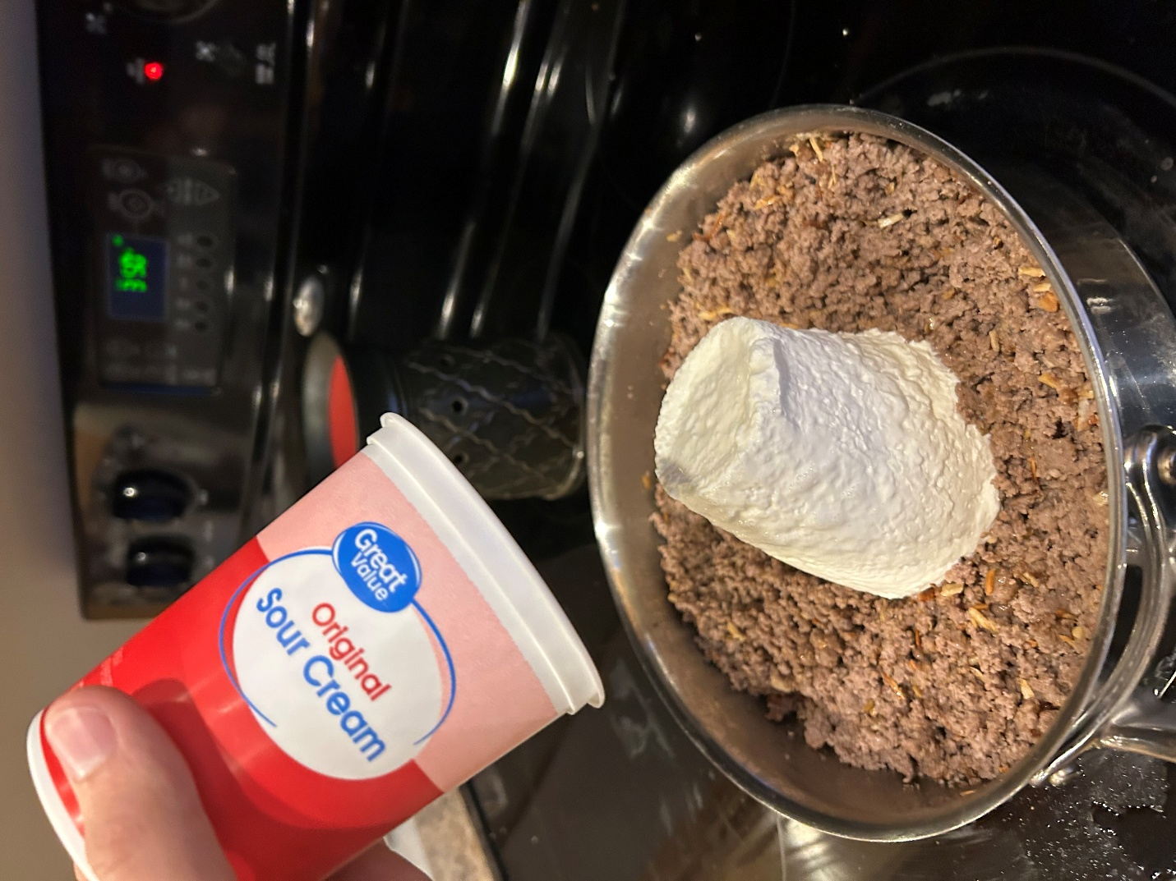

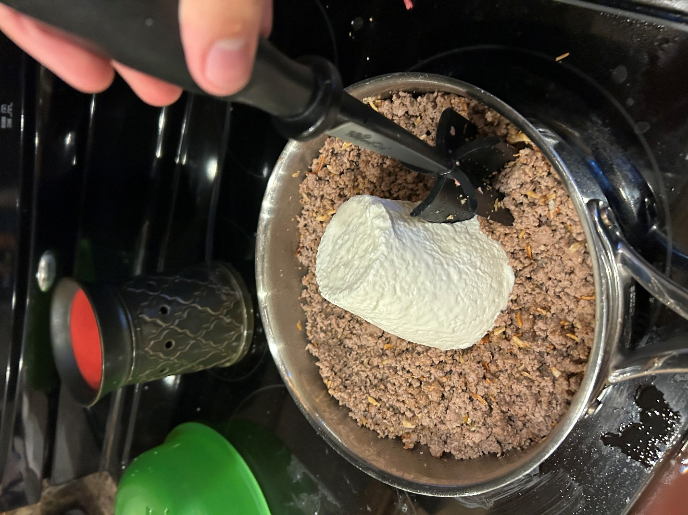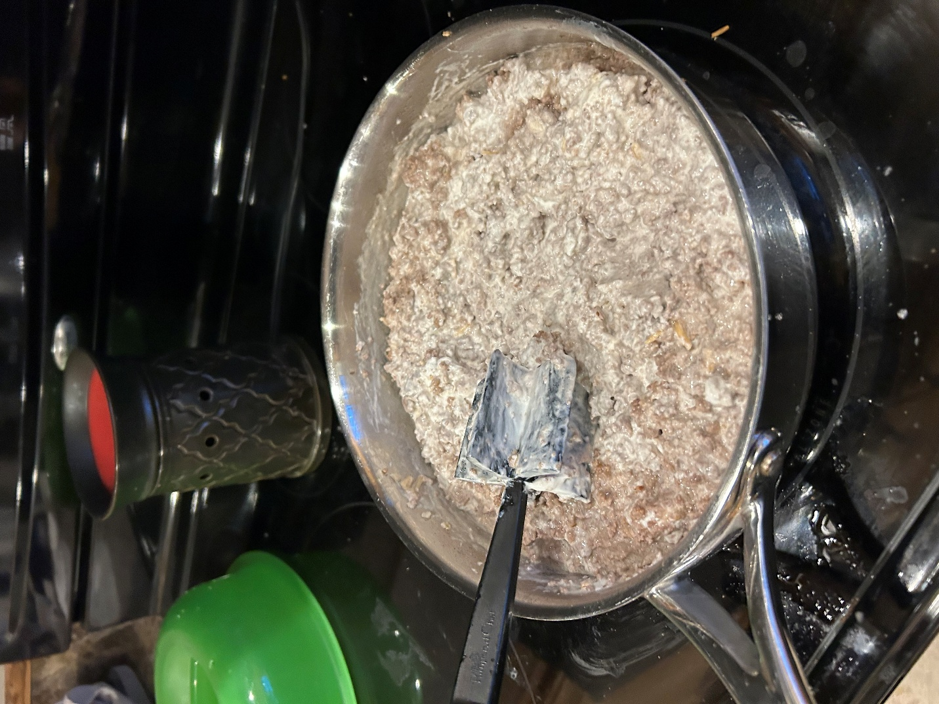

Step 11 – Acquire a 9x13 inch baking pan.

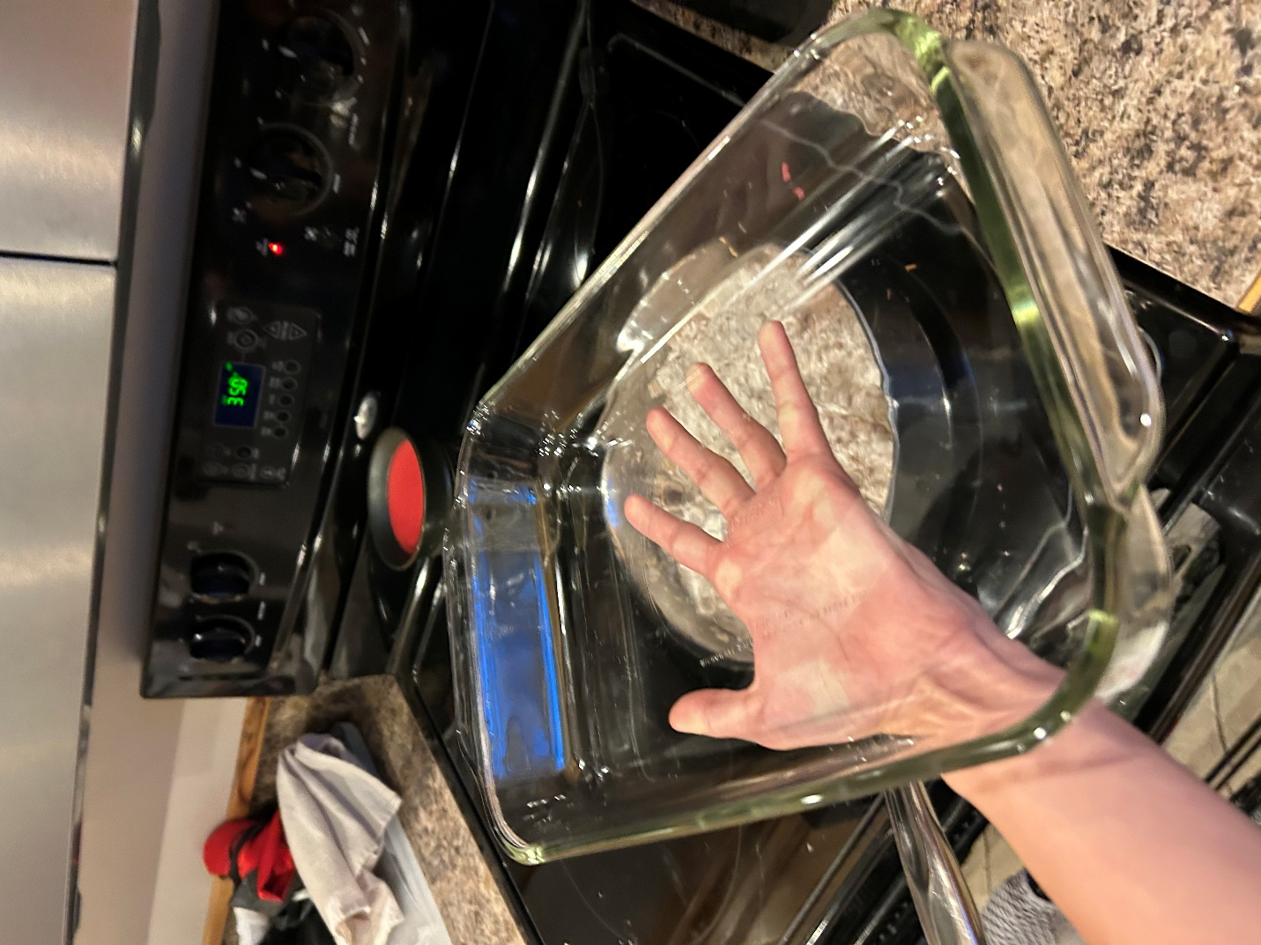

Step 12 – Gracefully pour the contents of your skillet into the pan. Be careful not to pour it all over the floor instead.

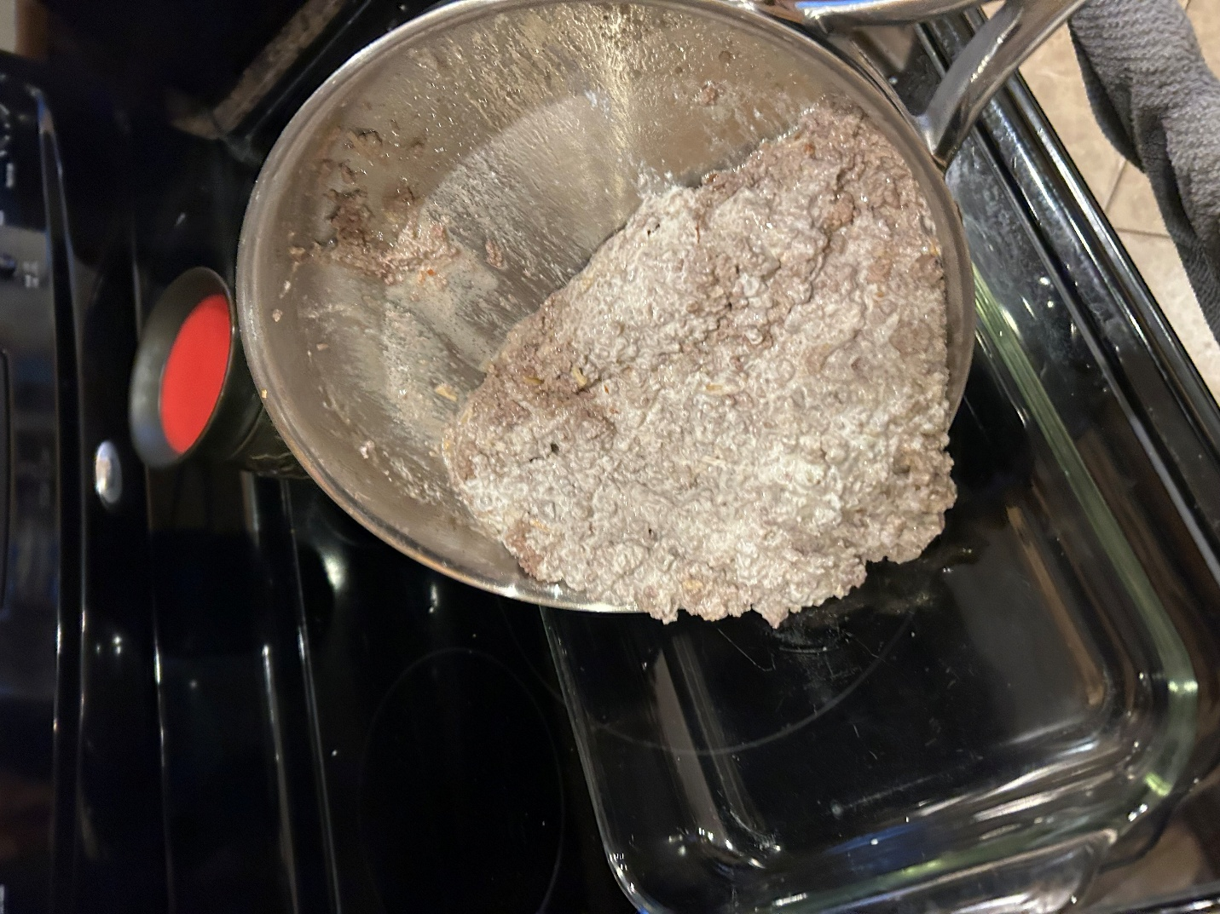

Step 13 – Spread the ground beef evenly throughout the pan.

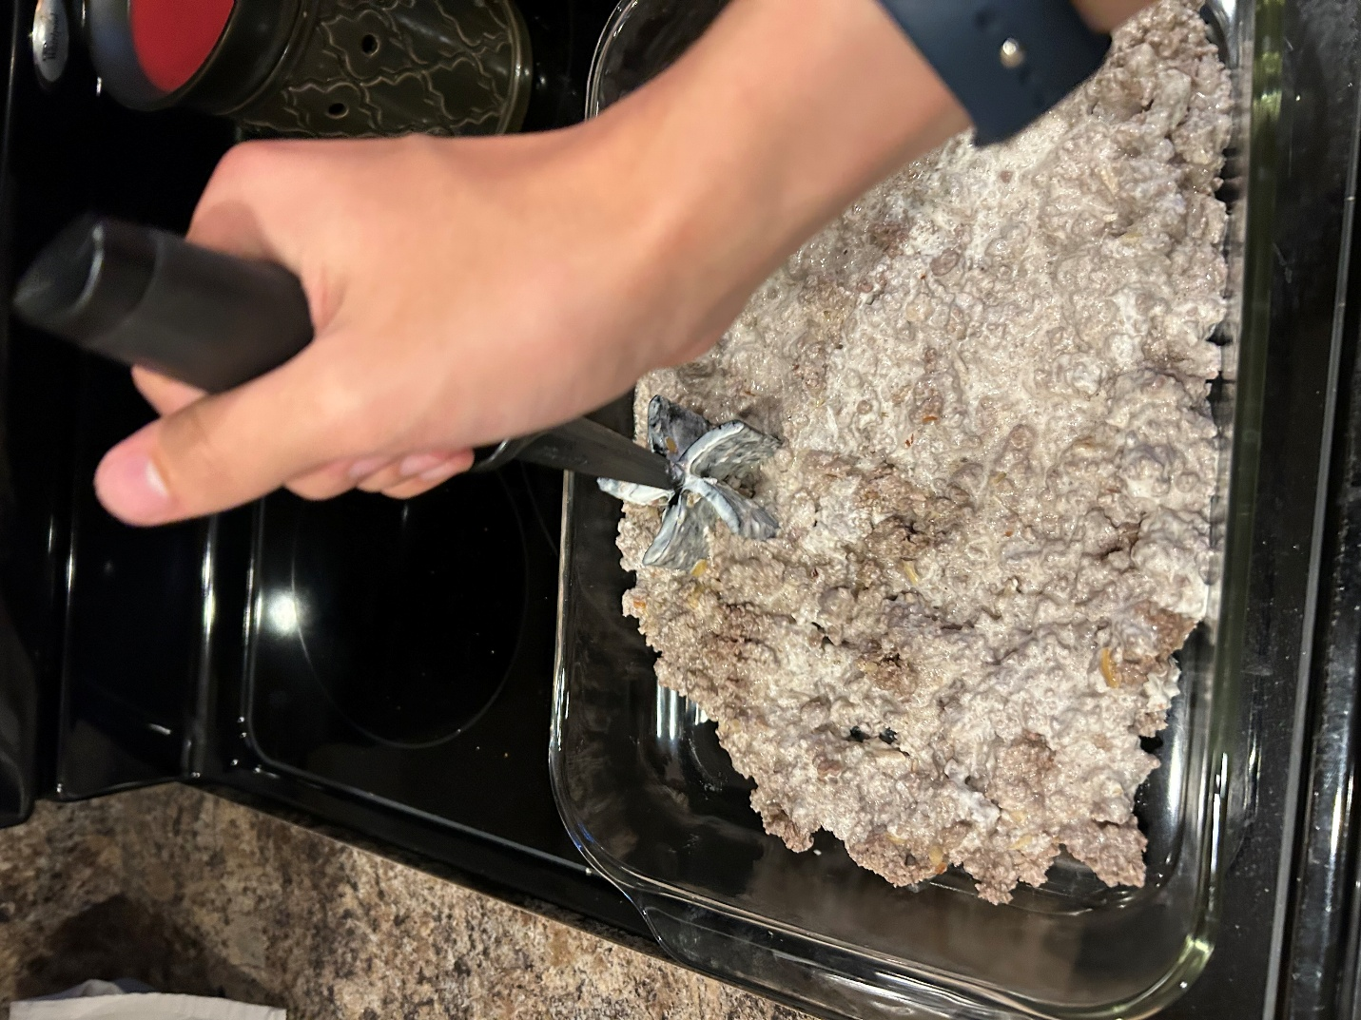

Step 14 – Acquire a bag of tater tots (you will need about 81, I used 83 in this recipe).

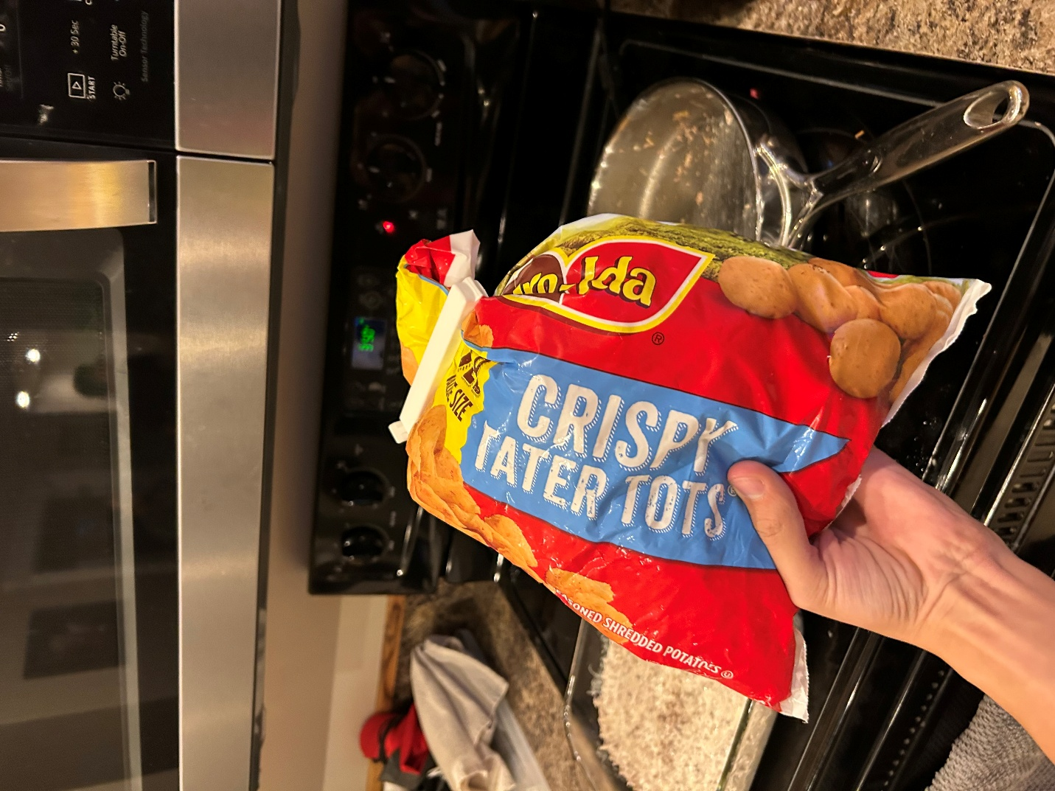

Step 15 – Geometrically place each tater tot over the pan until they create a blanket of spuds over your ground beef.

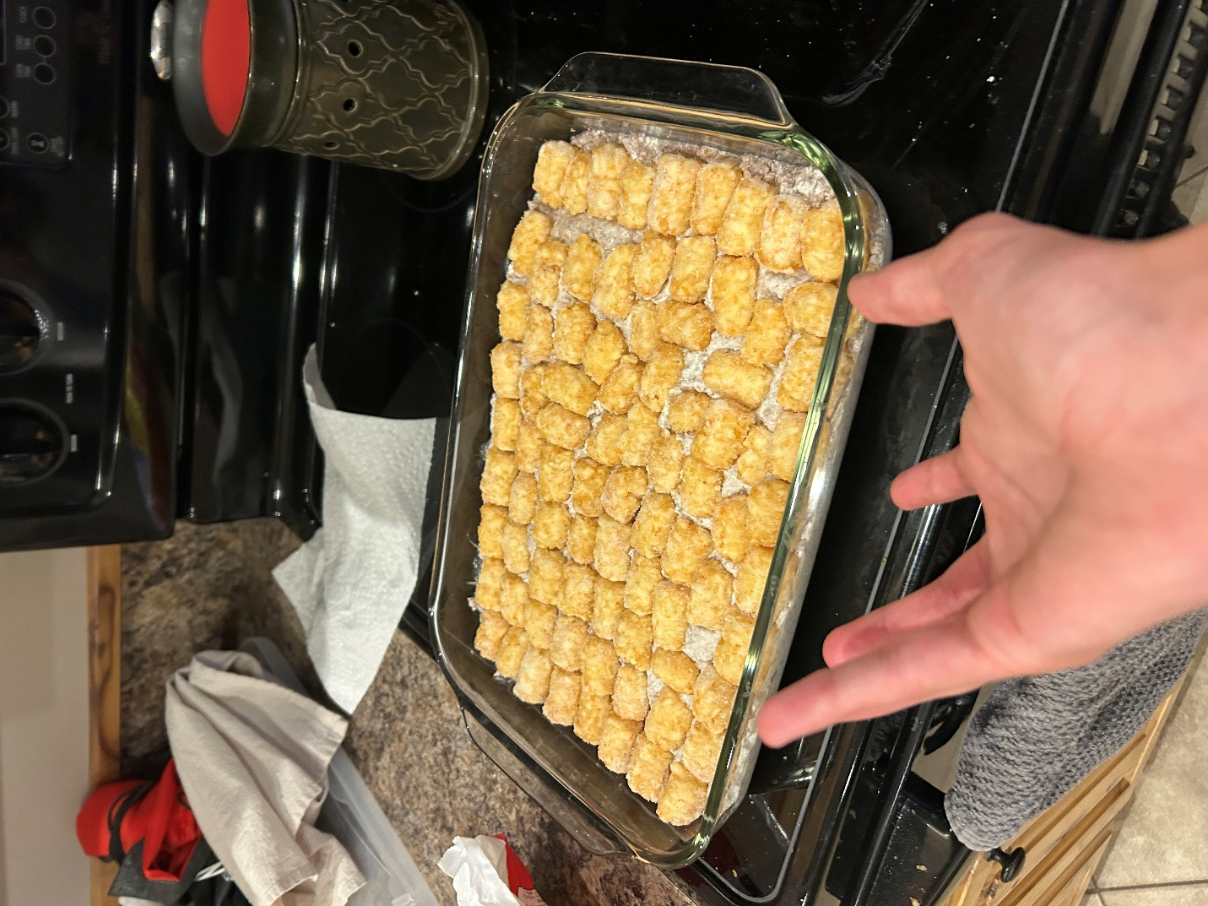

Step 16 -Acquire an oven mitt.

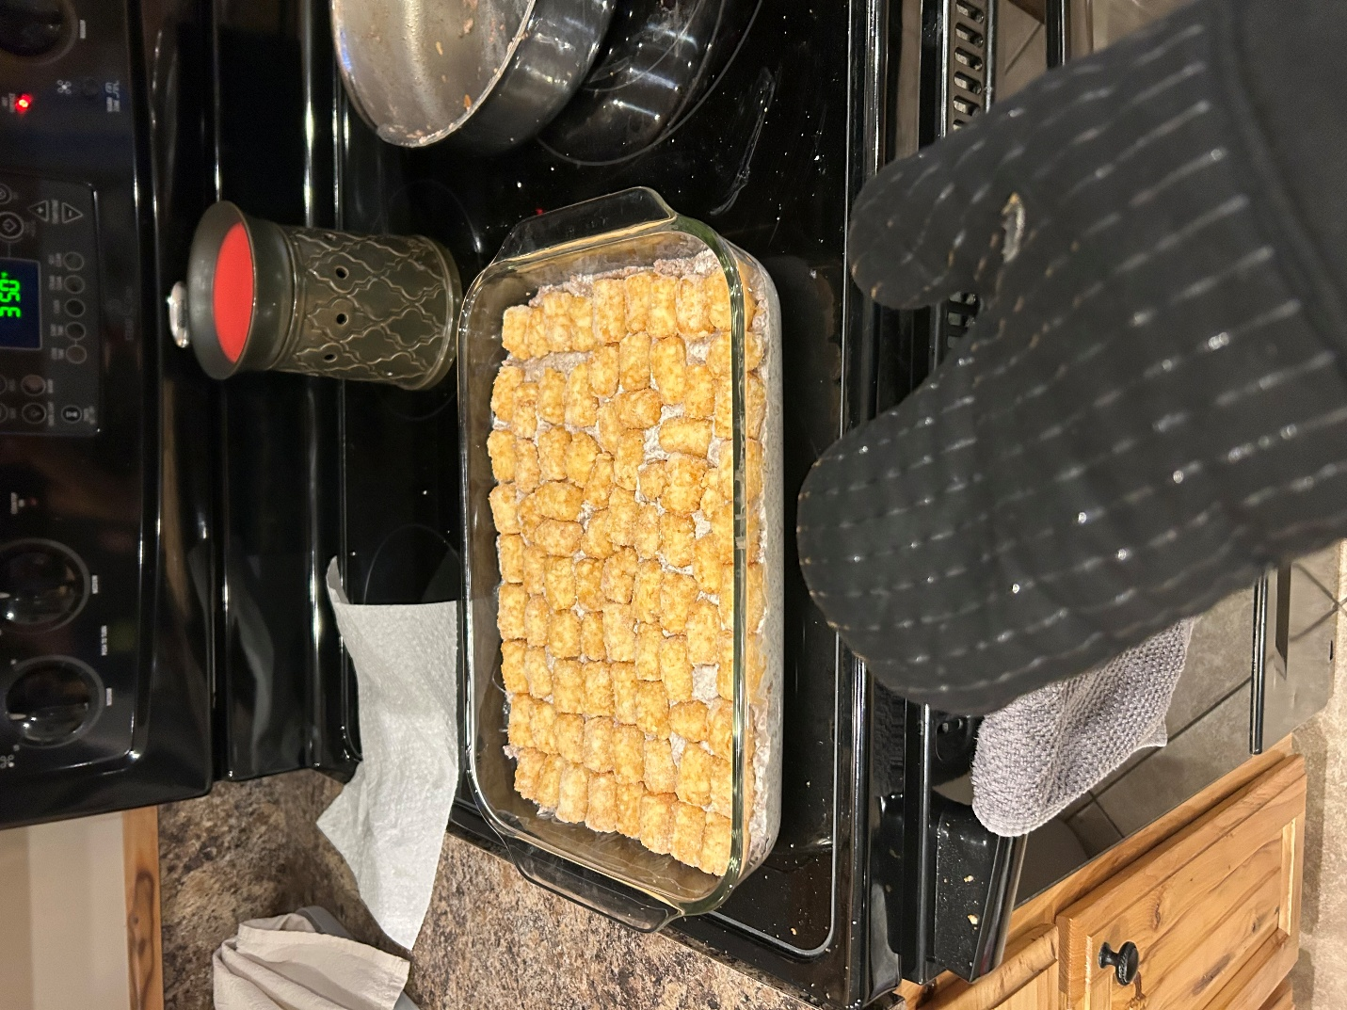

Step 17 – Place your casserole pan inside of the oven, making sure not to light yourself on fire. Leave the pan in the oven for 30 minutes. Once it finishes cooking, take the casserole out of the oven. Try not to eat it yet.

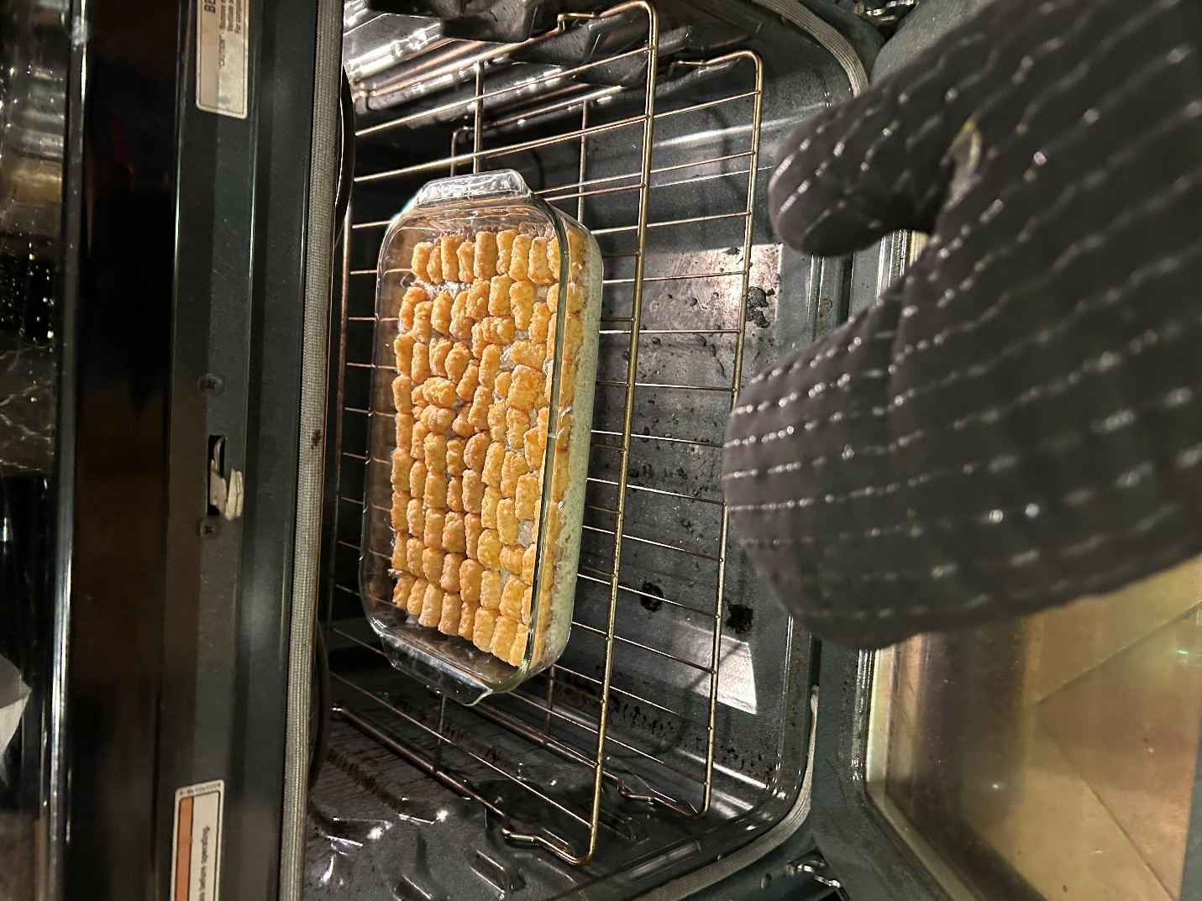

Step 19 – Acquire 2 cups of cheese (Colby jack is so good).

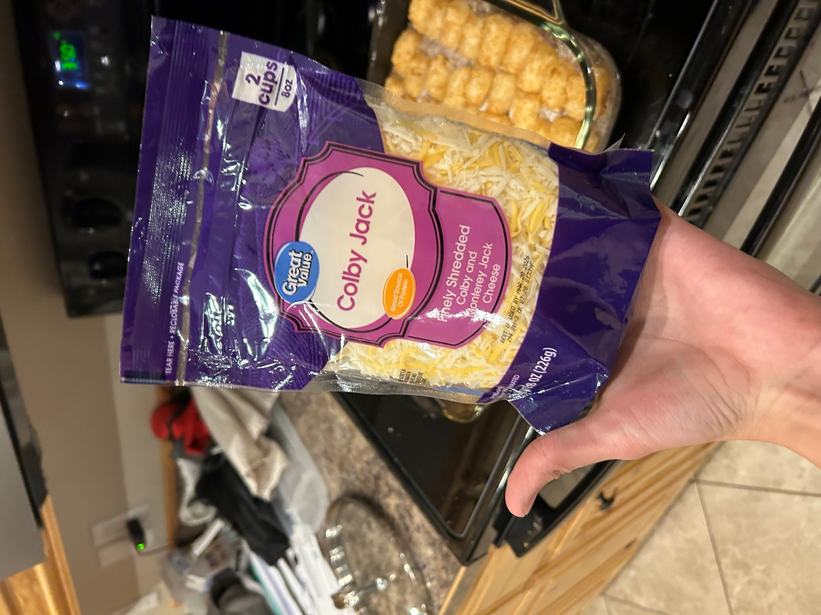

Step 20 – Spread the cheese all over the casserole until most of the pan is covered in cheese.

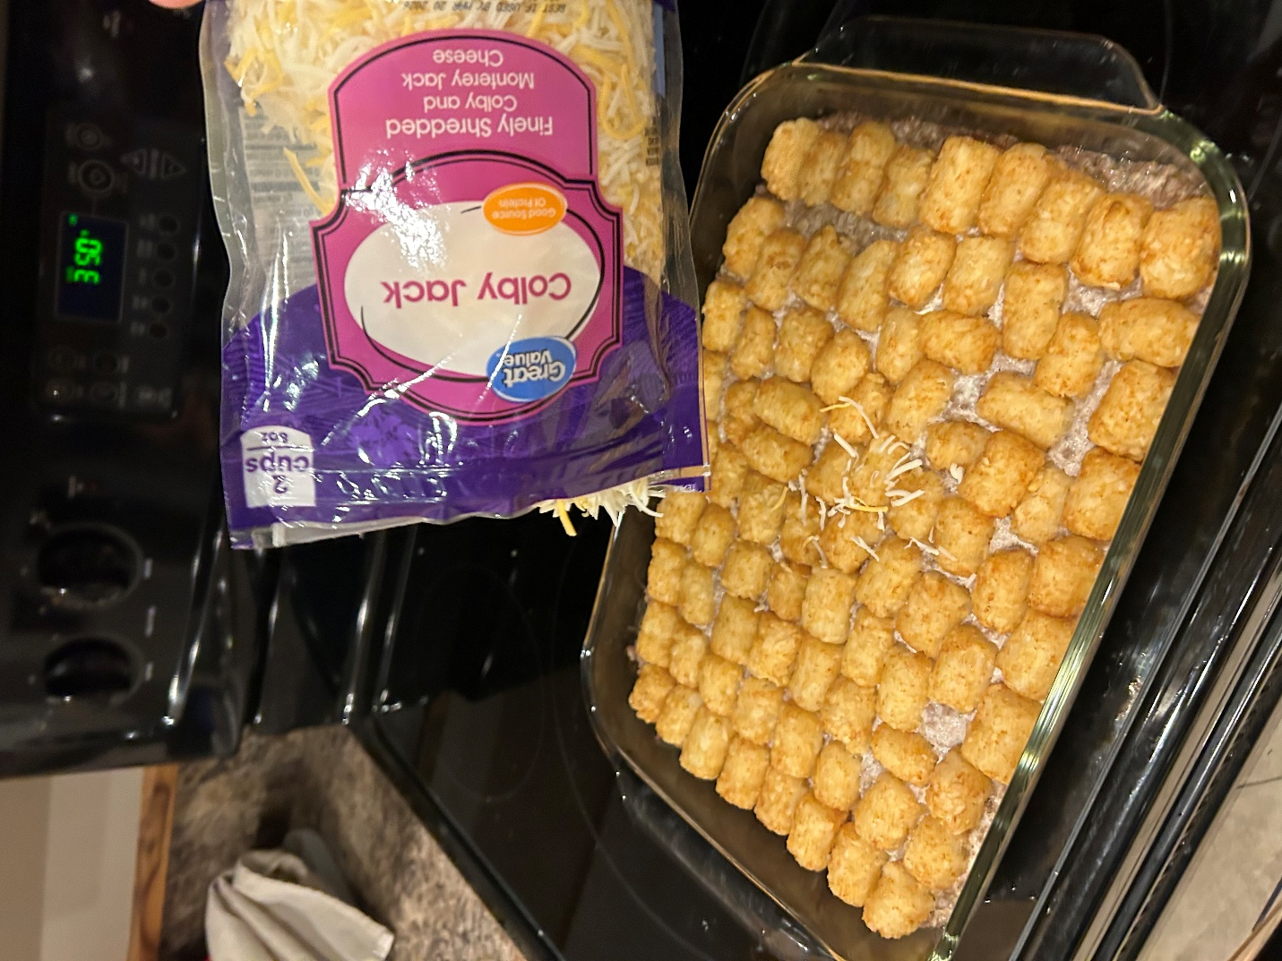

*You don’t need to add all of the cheese pictures if you don’t want to.*

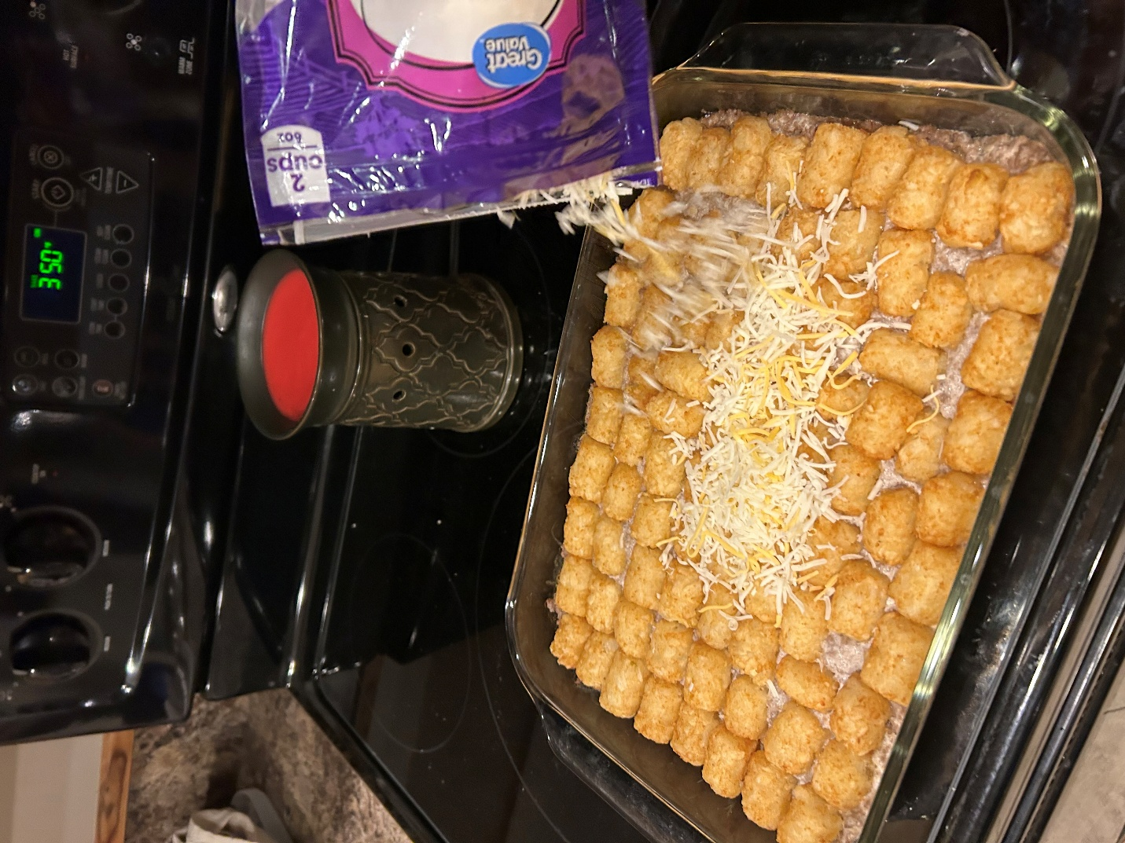 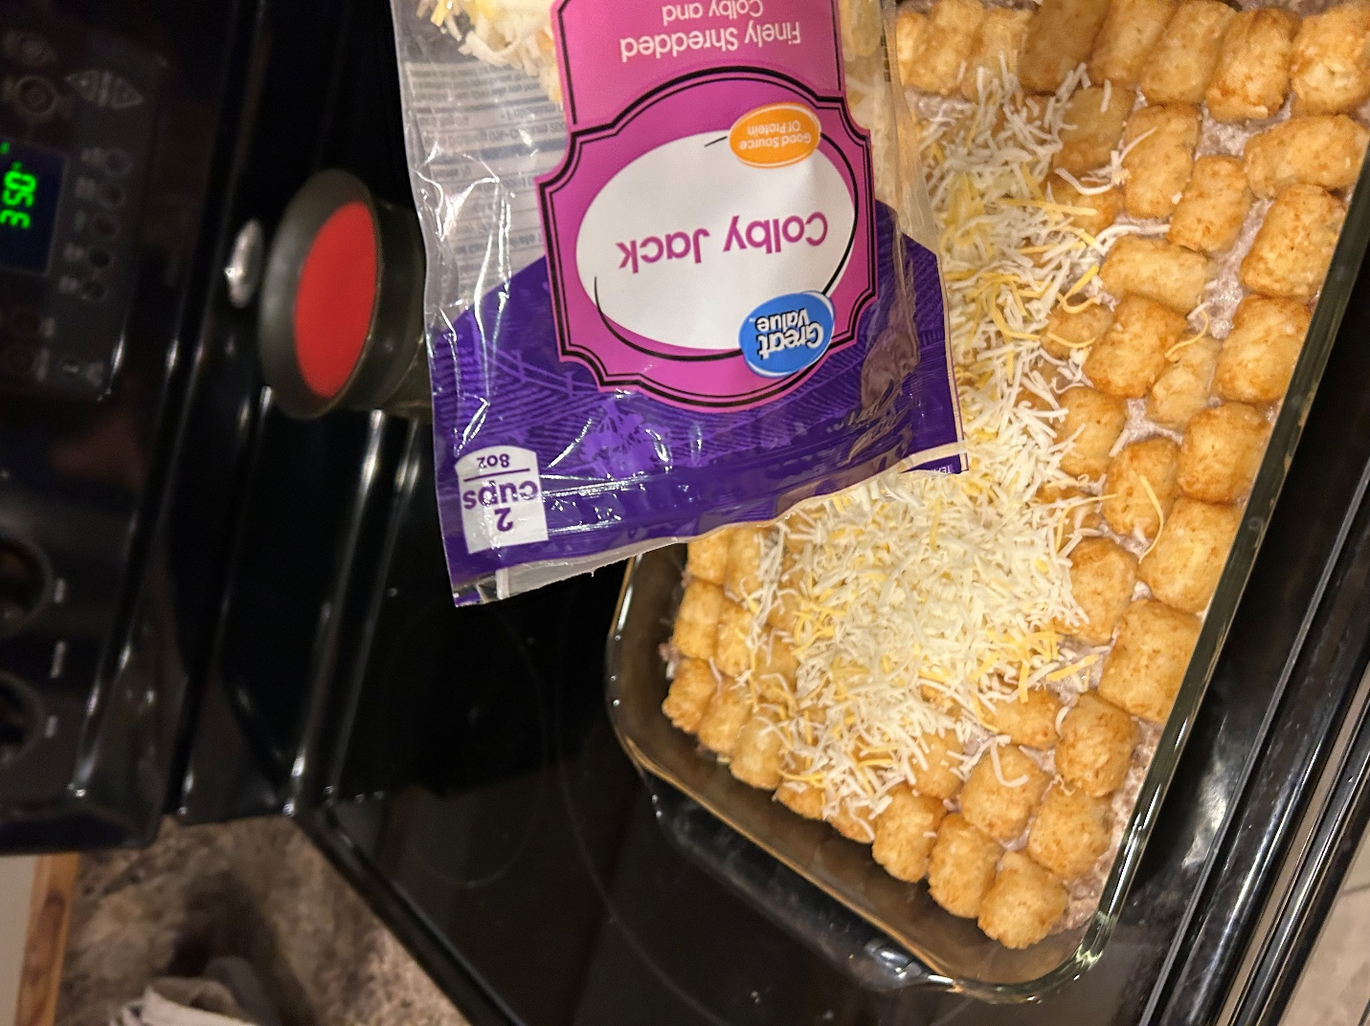 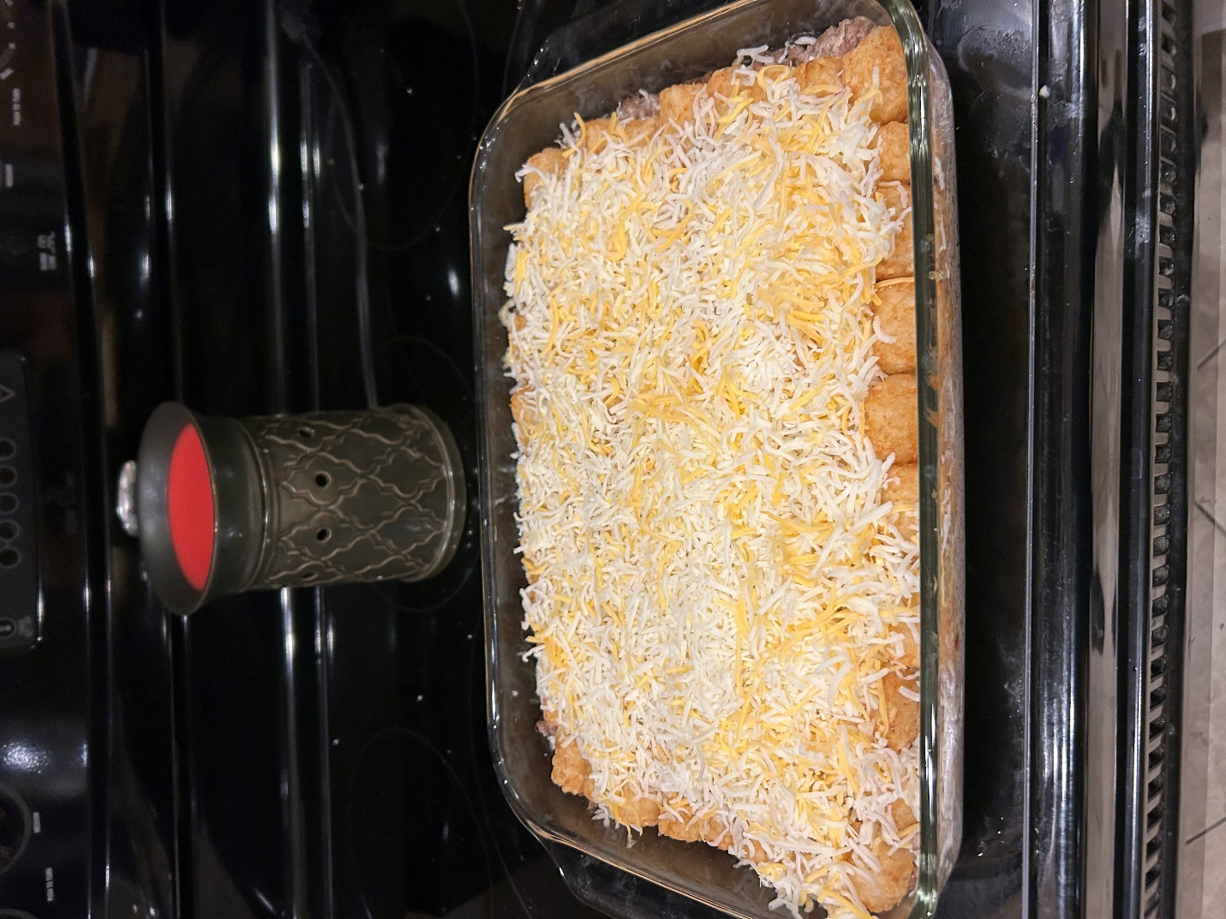

Step 21 – Place the casserole back in the oven; cook for another 5 minutes.

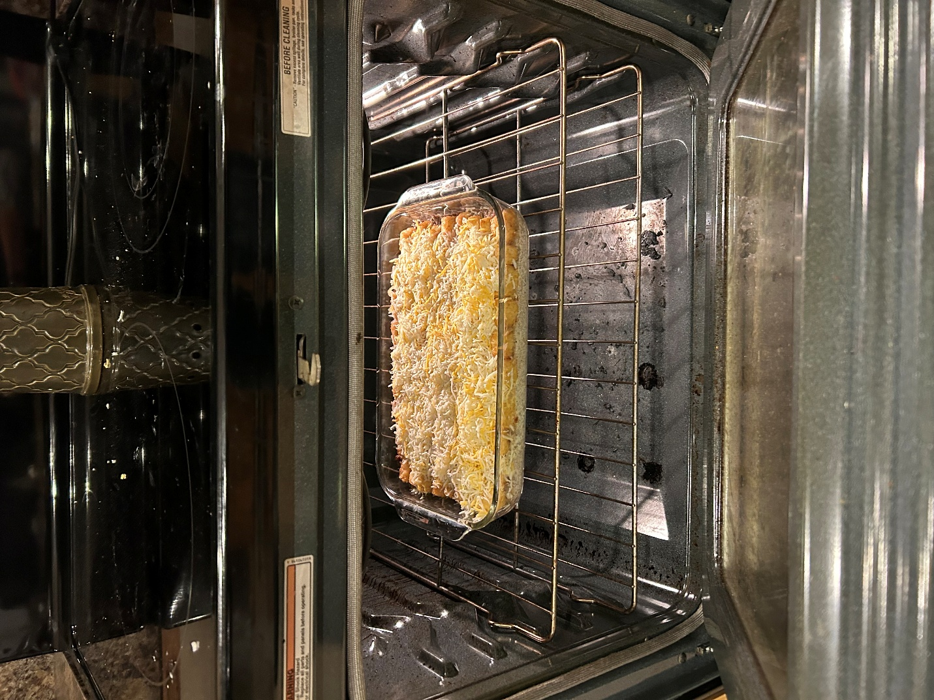

Step 22 – Acquire your finished tater tot casserole. 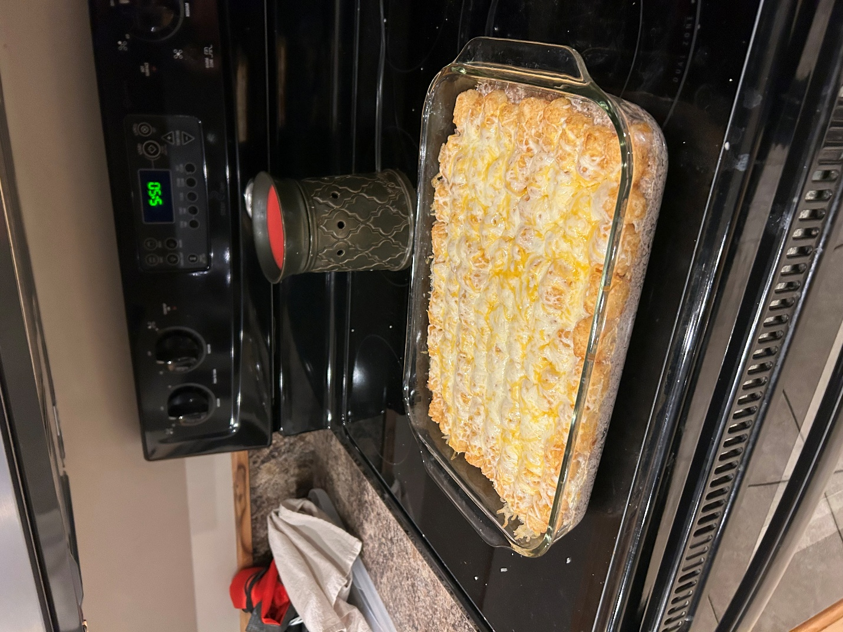

*Once again, you don’t need to add every picture here either. Just pick like 3 of the best ones. The unused pictures ought to go on the history page.*

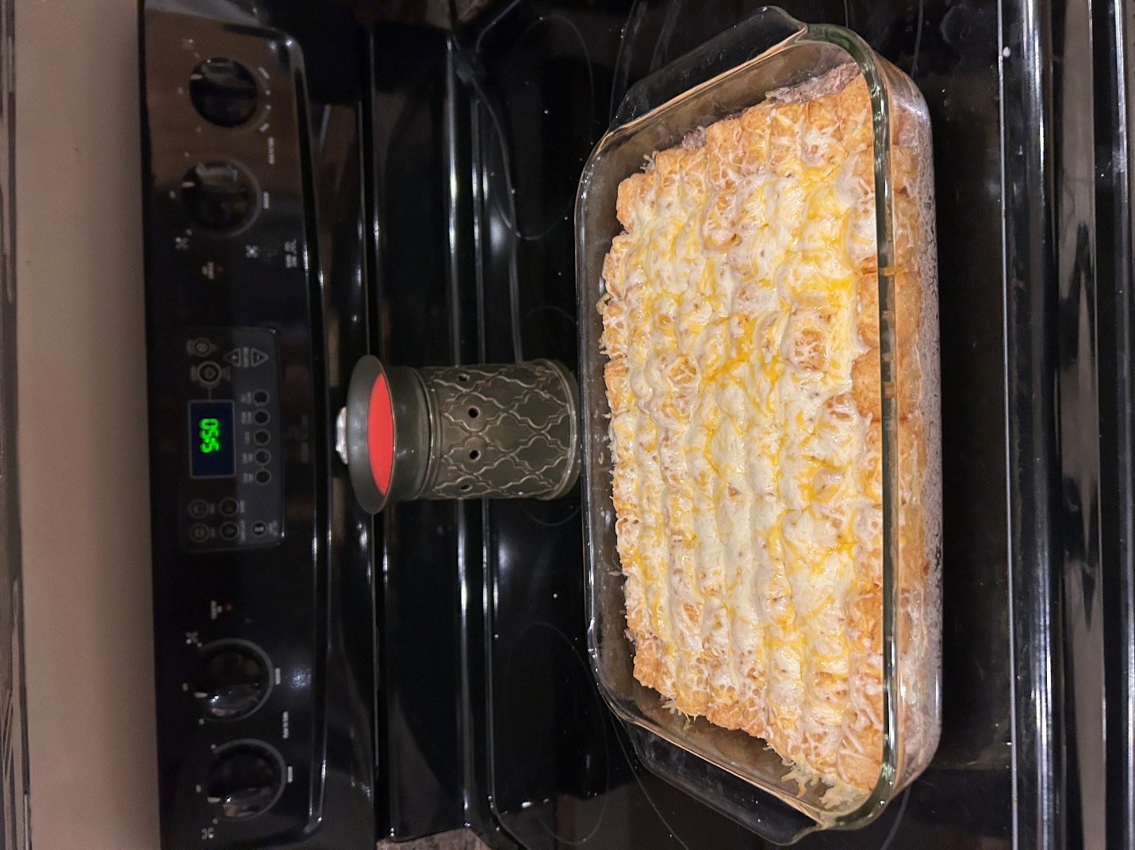

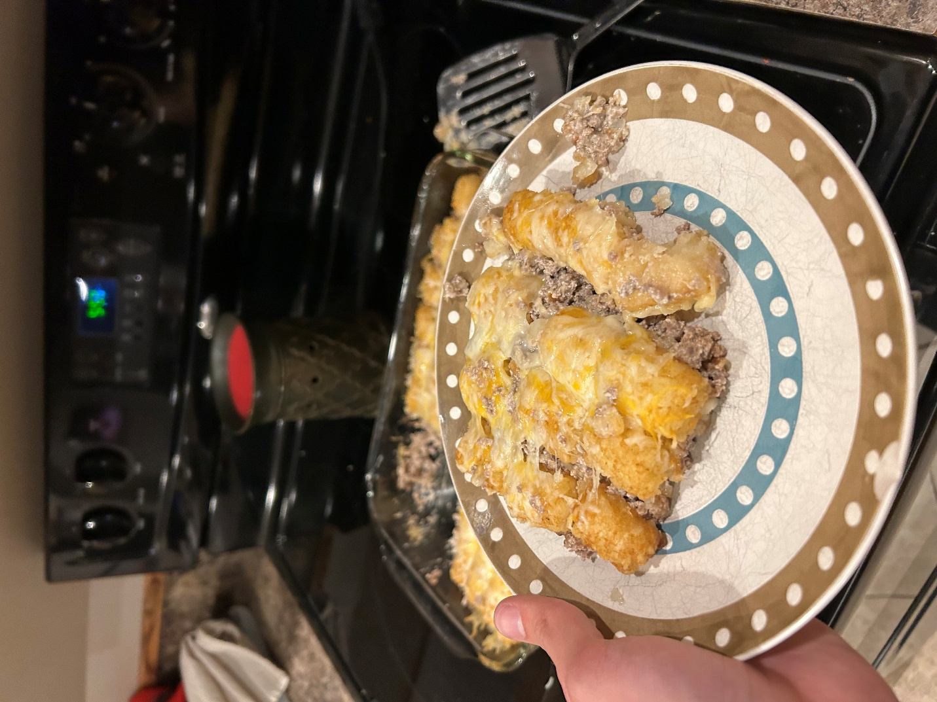

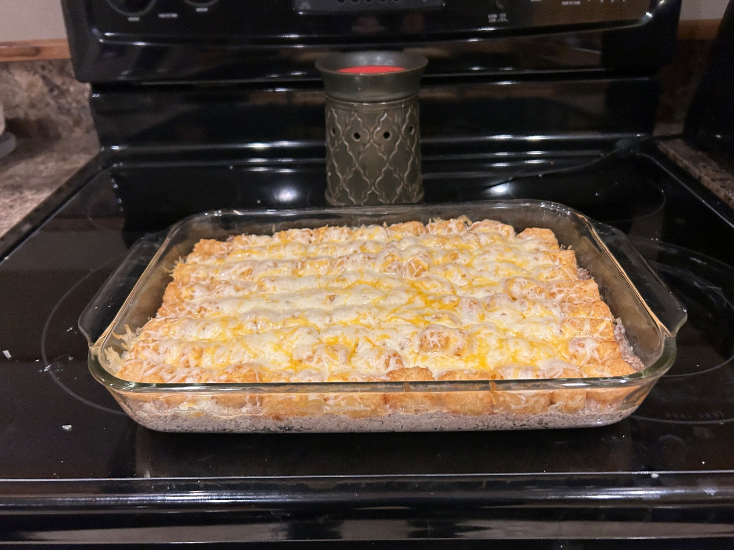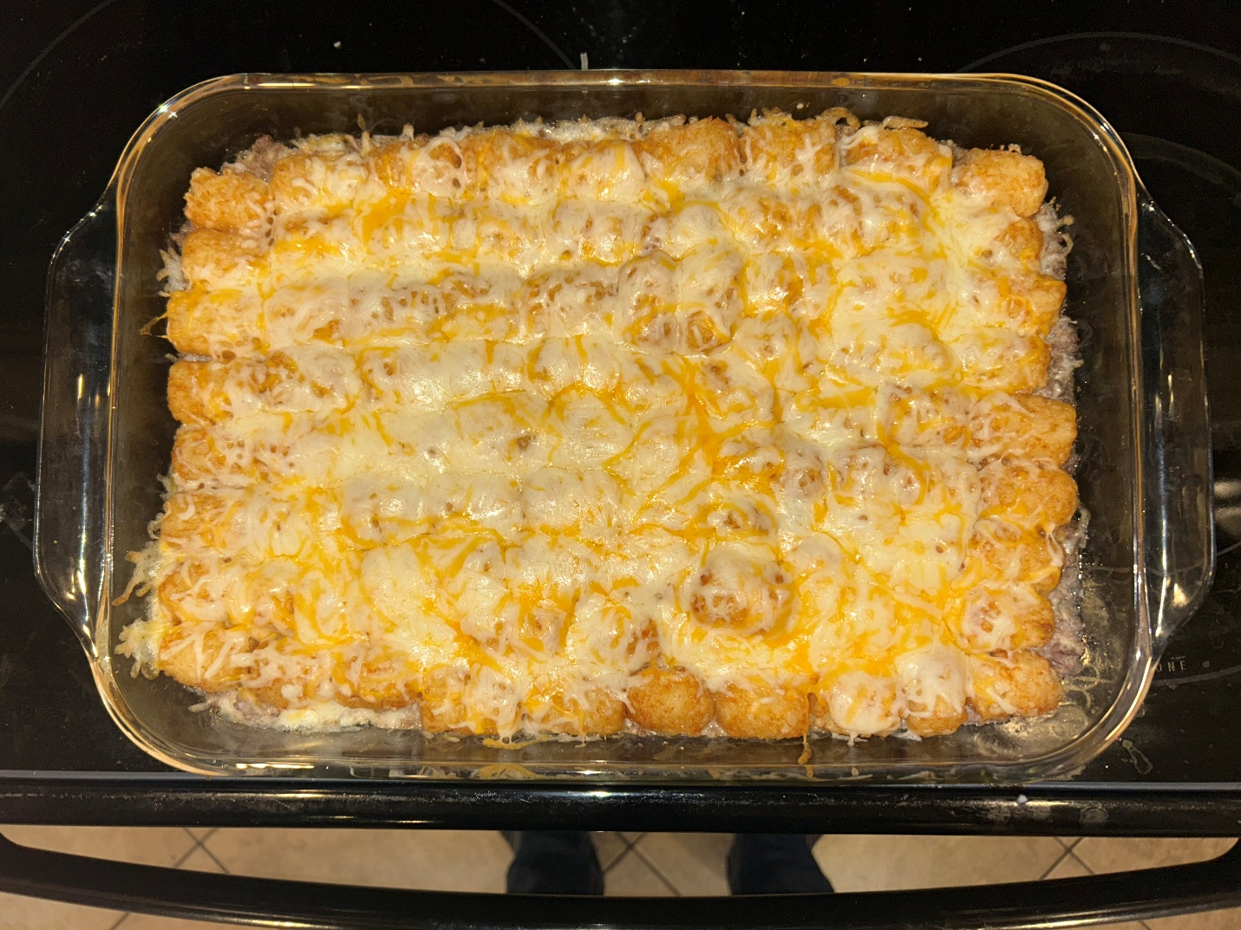

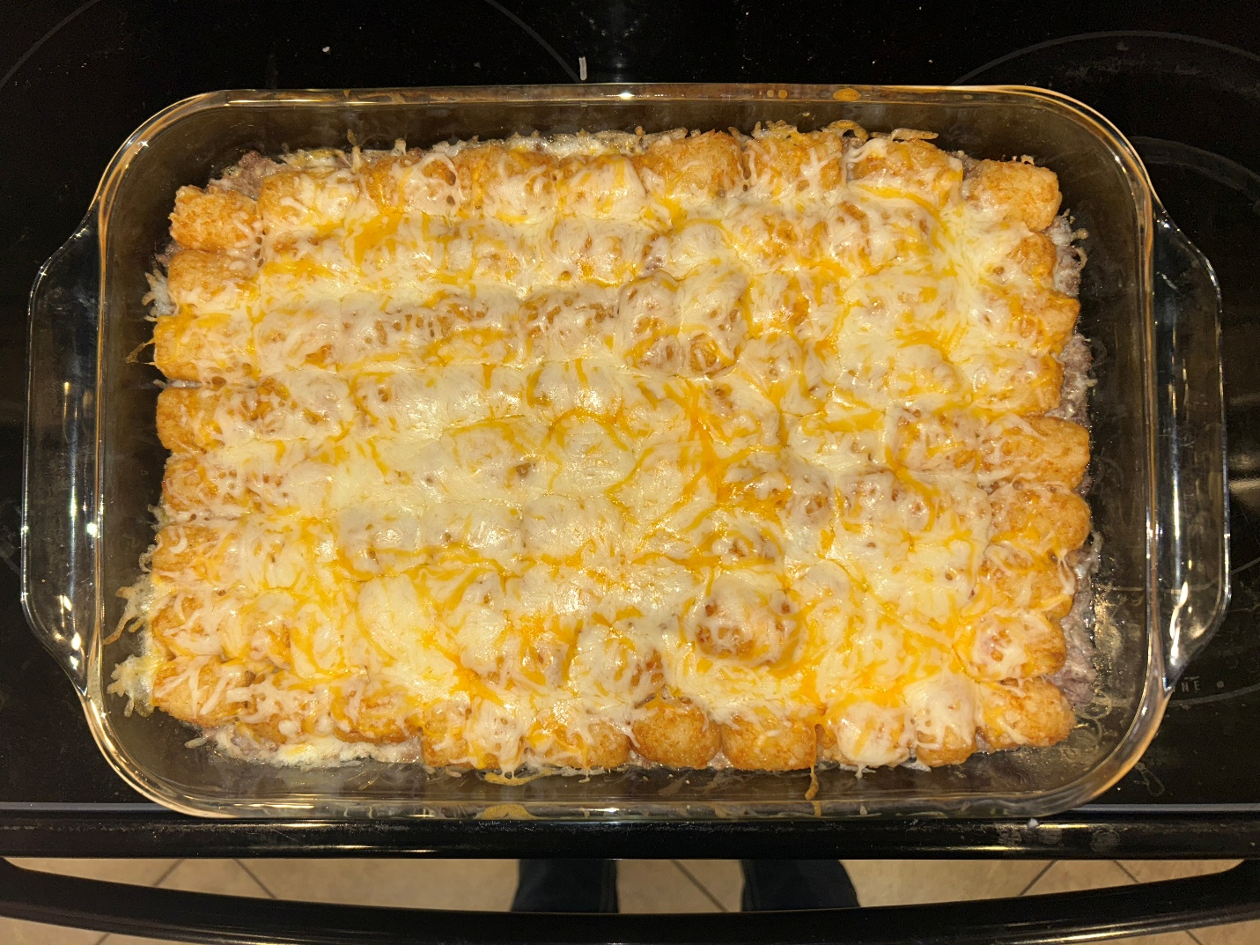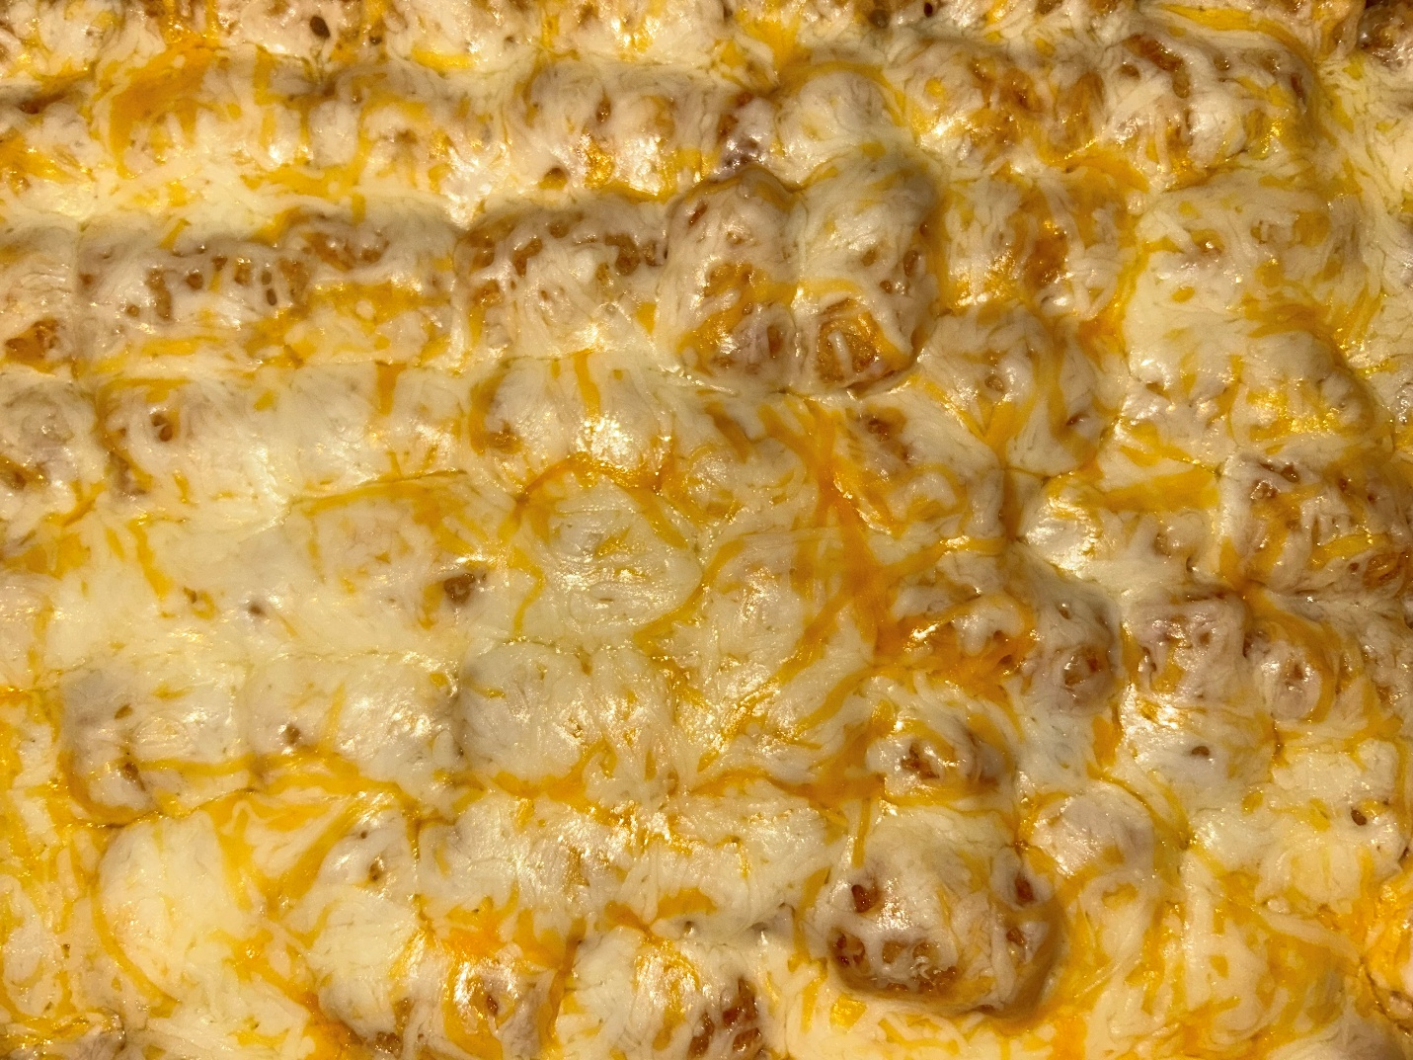

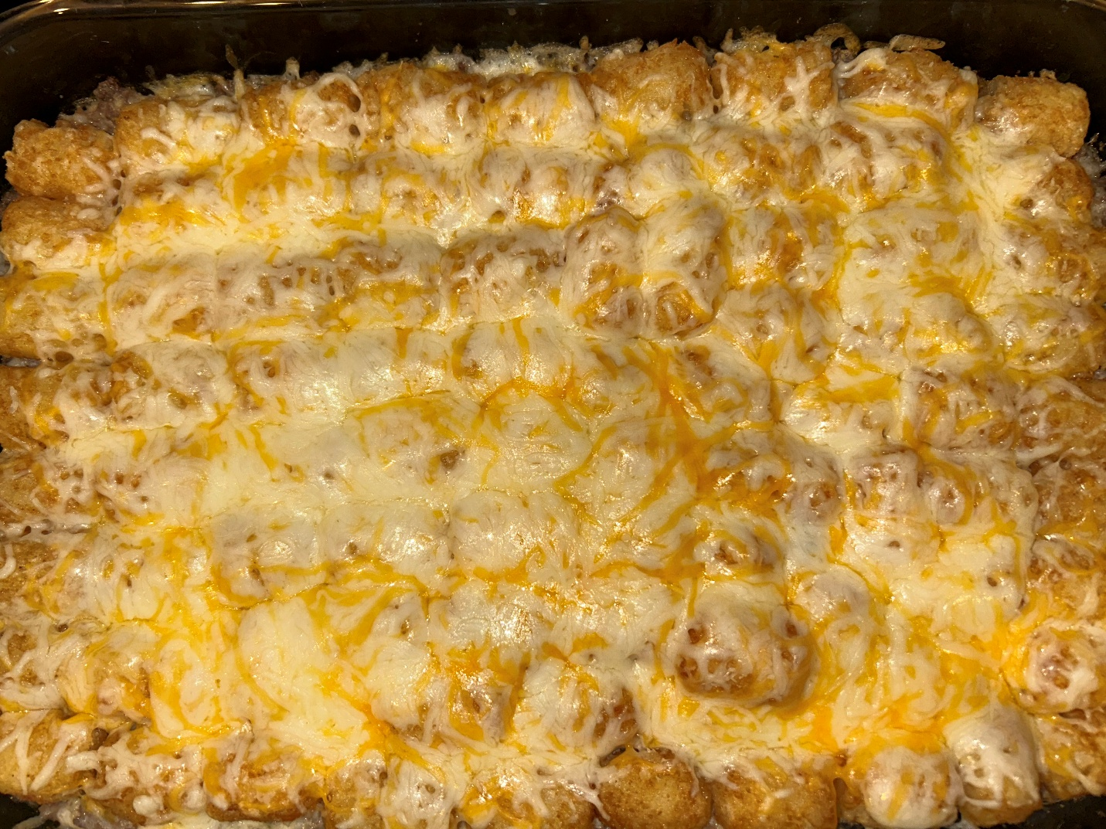

**Wireframes**

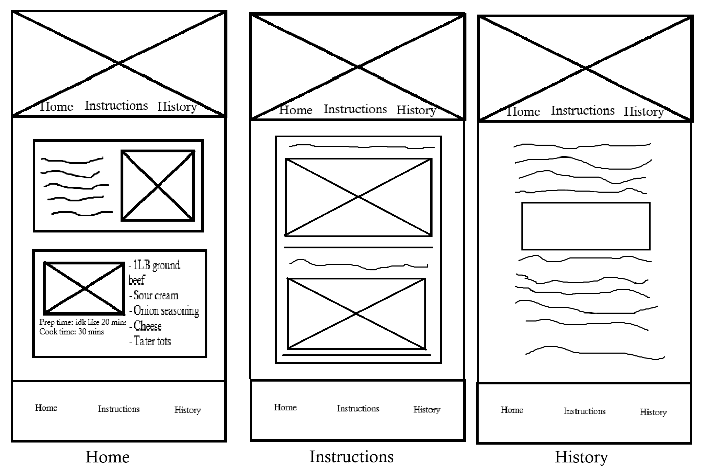

There should be more than 2 steps on the instructions page, I just ran out of room on the wireframe. It should look like:

Ingredients and cookware

Step 1

Picture

Horizontal Line

Step 2

Picture

Horizontal Line

…